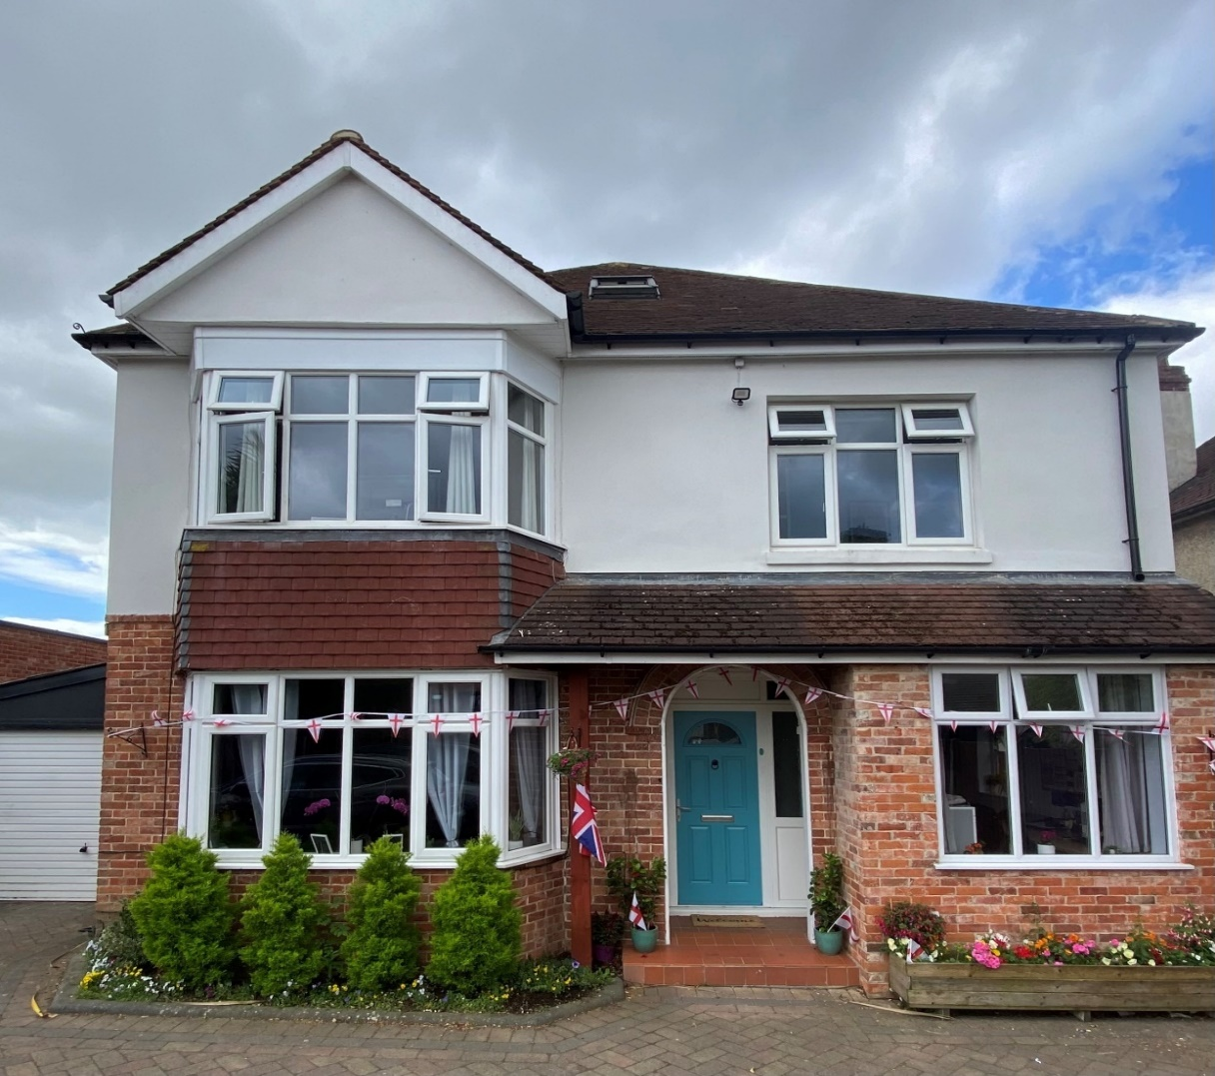
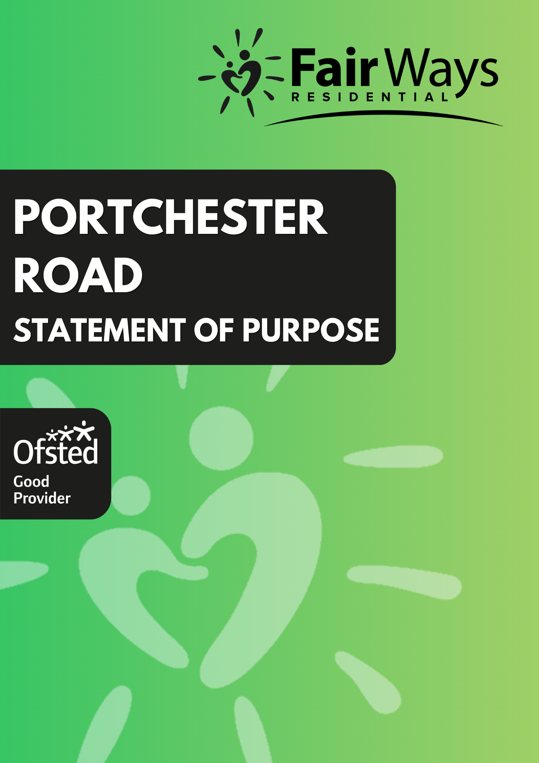
Our aim for Portchester Road is to facilitate progression in all areas of our Young People’s lives. This is achieved through a highly nurturing environment where our staff develop positive relationships and secure attachments, whilst developing their independence skills in preparation for moving onto adult life.

This Statement of Purpose has been prepared to meet the requirements of The Children’s Homes (England) Regulations 2015 Regulation 16 - (1) Schedule.

Contents

Quality and purpose of care

- Statement of the range of needs of the children for whom it is intended that the children’s home is to provide care and accommodation.
- Details of the home’s ethos, the outcomes that the home seeks to achieve and its approach to achieving them.

- A description of the accommodation offered by the home, including
  - How accommodation has been adapted to the needs of children.
  - the age range, number and sex of children for whom it is intended that accommodation is to be provided.

- A description of the location of the home.

- The arrangements for supporting the cultural, linguistic and religious needs of children.

- Details of who to contact if a person has a complaint about the home and how that person can access the home’s complaints policy.

- Details of how a person, body or organisation involved in the care or protection of a child can access the home’s child protection policies or the behaviour management policy.

Views, wishes and feelings

- A description of the children’s homes’ approach to consulting children about the quality of their care.

- A description of the home’s policy and approach in relation to Anti-discriminatory practice in respect of children, their families and children’s rights.

Education

Arrangements for young people to attend local schools, promoting educational achievement and supporting young people with special educational needs.

Enjoyment and achievement

11. The arrangements for enabling children to take part in and benefit from a variety of activities that meet their needs and develop and reflect their creative, intellectual, physical, social interests and skills.

Health

12. Details of any healthcare or therapy provided, including-

- Details of the qualifications and professional supervision of the adults involved in providing any healthcare or therapy.

- Information about how the effectiveness of any healthcare or therapy provided is measured, the evidence demonstration its effectiveness and details of how the information or the evidence can be accessed.

Positive relationships

13. The arrangements for promoting contact between children and their family and friends.

Protection of children

- A description of the children’s home’s approach to the surveillance and monitoring of children.

- Details of the home’s approach to behavioural support, including the home’s approach to restraint in relation to children and how staff are trained & assessed.

- The home’s approach to restraint in relation to children

(b) How adults working in the home are trained in the restraint process and how their competence is assessed.

Leadership and management care planning

- The name and work address of-

- The registered provider.
- The responsible individual.
- The registered manager.
- Details of the experience and qualifications of adults, including any adults commissioned to provide education or health care.
- Details of the management and staffing structure of the home, including arrangements for the professional supervision of adults, including adults that provide education or health care.

Care planning

17. Any criteria used for the admission of children to the home, including any policies and procedures for emergency admission.

18. Ongoing Planning.

Quality and purpose of care

1. The range of needs of the children and admission criteria

Portchester Road provides care for up to five children who require a stable, nurturing, and therapeutically informed environment. Many of the children have experienced significant adversity, disrupted relationships, or trauma, and therefore benefit from a relational approach that prioritises emotional safety, predictability, and trust. The home supports children aged 12–18 with a diverse range of social, emotional, and behavioural needs, including neurodiverse profiles such as Autistic Spectrum Disorder and Attachment Difficulties.

Our trauma-informed model recognises that children’s behaviours are often adaptive responses to earlier experiences. Staff work sensitively to understand these underlying needs, using attuned, consistent relational interactions to promote regulation and a sense of safety. The home is designed to meet children’s developmental, sensory, and emotional needs so they can engage positively in daily life and education.
Admissions are carefully assessed to ensure the home can meet each child’s needs while maintaining group stability, recognising that trauma-affected children require thoughtful matching and secure base from which to heal.

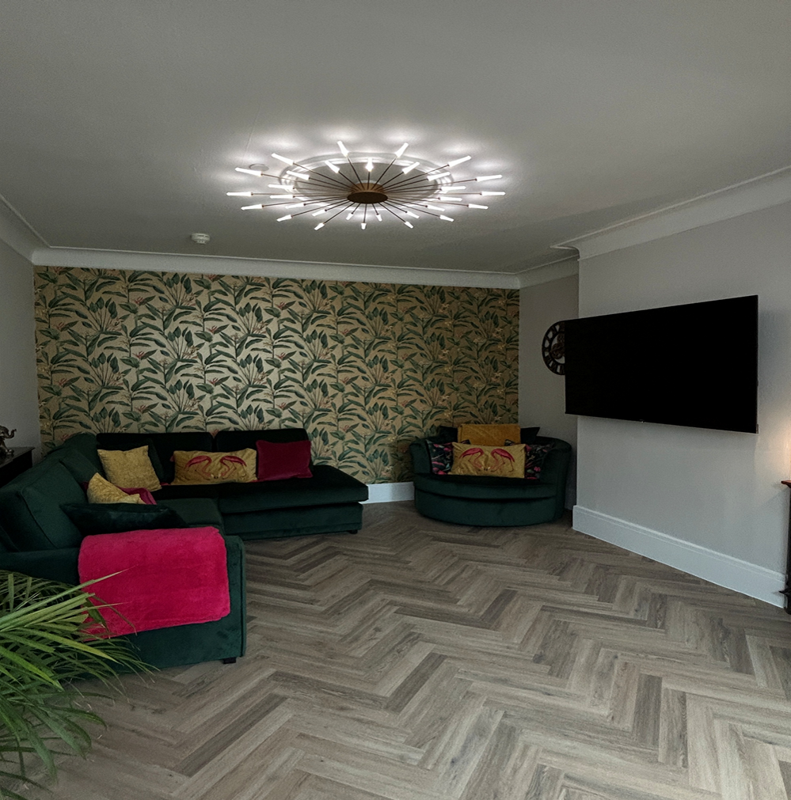

2. Ethos, outcomes and approach


Portchester Road is grounded in a relational, trauma-informed approach that places connection, attunement, and emotional safety at the centre of everyday care. We believe that children make progress through consistent, nurturing relationships where they experience trust, predictability, and responsive caregiving supporting them to build secure attachments, strengthen resilience, and develop the independence skills needed for adulthood.

Portchester Road is an Ofsted-registered children’s home (URN: SC385809) and operates in line with relevant legislation, regulations, and statutory guidance.

The home is part of Fair Ways Community Benefit Society, which provides a range of services including a therapeutic hub, education provision, supported living, family contact centres, fostering, and outreach support.

Staff work closely with the Fair Ways Hub and other clinical professionals to ensure assessments, placement planning, behaviour support planning, and agreed interventions are evidence-informed and trauma-responsive. This collaborative approach supports a coordinated, consistent environment in which children’s strengths are recognised, and their voices help to shape their plans and day-to-day experiences.

The home provides the following services and support:
- 24h care, 365 days per year
- Access to full range of health care services
- A therapeutic needs assessment by Fair Ways hub within first three months of the placement
- Access to sensory profile assessment if required.
- Access to individual therapeutic intervention if required.
- Supporting and facilitating family time
- Range of activities, hobbies, clubs, opportunities and holidays
- Preparation for transition to independence
- Preparation for reunification with family

Alongside day-to-day care and practical support, we use trauma-informed, relational practice to help children feel safe, understood, and supported to develop secure attachments and emotional stability.

Fair Ways Values

‘Fair Ways have four core values. Each and every member of Fair Ways is expected to play their PART (Professionalism, Acceptance, Curiosity & Transparency) and help others do the same. These are the lifeblood of our culture and are not negotiable.’

Professionalism: We do what we say we will. We approach challenges with optimism and enthusiasm. We don’t judge, we notice. We put the needs of the service before our own personal gains.

Accepting: We don’t give up on people, we value all individuals and are willing to challenge them. We embrace each other’s differences as much as our similarities. We accept responsibility for our actions.

Curiosity: We give feedback, we invite feedback, we listen to feedback. We look inward before we look outward. We learn as much from our mistakes as from our successes. We listen to each other, learn from each other and grow together.

Transparency: We are always willing to explain why. We have courage to be open and honest. We live by our values even when no one is looking. We earn trust through transparency.

OUR HOME Values

Education and Employment:
Every Young Person at Portchester Road is supported to engage in education and is aware of employment opportunities specific to their individual needs. We believe that education is extremely important to our Young People’s further opportunities and Young People are encouraged to be in a routine to support them with this. We also have an Education Specialist at our Fairways Hub who can support the team if we have Young People lacking engagement in education.

Independent Living:
We encourage all our Young People at Portchester Road to explore their abilities and fulfil their potential as they move on from residential childcare to independence, learning the necessary skills along the way. This is discussed in their Pathway Plan meetings and then an individual independence plan is developed with both our Young Person and Keyworkers to enable them to gain the life skills required for a successful transition.

Health and Wellbeing:
Our Young People’s health and wellbeing is of upmost importance and is supported by the culture at Portchester Road. Through positive relationships in the Home our Young People can identify and understand their own needs, the support that is available and over time be able to manage this independently. This is encouraged through staff supporting with medical appointments and Young People creating their own Zoning Plan relating to their behaviours and recognising the support they require when in certain zones relating to their emotions.

Community and Friendships:
Young People and staff are to be involved in the community both at Portchester Road and in the local area, successfully preparing them towards

independence in the future. We hold weekly community meetings and encourage participation in hobbies and activities individually and as a group. We also have a locality risk assessment providing us with details of local services which are available.

The Teams Accountability to Each Other:
As a team we strive to create the best possible opportunities for our Young People to succeed as they leave residential childcare. We hold ourselves accountable to the following three commitments:

  - Integrity: Doing what we say we are going to do.
  - Trusting Team: Take on board feedback about our own practice.
  - Everyday Matters: Not put off what can be achieved today.

Therapeutic Model

We aim to give the young people a home that can help them in the process of recovery from developmental trauma. Recognising that the healing process depends on the quality and strength of our relationship with the young people we care for. Our model of therapeutic practice is informed by attachment-based theories and its specific practical implementation tool in the form of PACE as a guide for the way we interact and relate to the young people.

There is a common misconception that being a therapeutic placement means that young people will receive structured therapy, from a professional. This kind of therapy is likely to be a very tiny piece of the overall support that is needed for the young people.

PACE is a therapeutic approach and guide for every day-to-day interaction with others that can be a powerful tool for us, the staff, to build strong connections with the young people in our care. It emphasizes four key qualities:
- Playfulness: This involves using a light-hearted and engaging tone during interactions. It's about creating a fun atmosphere that helps young people feel comfortable expressing themselves freely.
- Acceptance: This means unconditionally accepting a young person's feelings and thoughts, even the negative ones. It's about communicating that we understand and value their emotional experience.
- Curiosity: This involves going beyond simply reacting to a young person's behaviour and instead trying to understand the underlying reasons behind it. We can achieve this by asking open-ended questions and seeking their perspective.
- Empathy: This means showing young people that we truly understand and care about their feelings. It's about validating their emotions and offering support.

By incorporating these qualities, PACE helps young people feel safe and secure within their relationship with us, the staff. This sense of safety allows them to better regulate their emotions, develop a positive self-image, and build strong social and emotional skills.
Ultimately, PACE fosters trust and connection between us and the young people, leading to more effective communication and co-operation.
There is a common misconception that being a therapeutic placement means that young people will receive structured therapy, from a professional. This kind of therapy is likely to be a small piece of time within the overall support that is needed for the young people. The House Model of Parenting is what we have chosen at our home as our guide for the staff on how to support the young people.

All children thrive when they experience emotional connection alongside behavioural support. Developmentally traumatised children can only begin to recover when they experience this.

Our role is to build this foundation through:
- Consistency and Predictability: Establishing clear routines and expectations provides a sense of stability and fosters a feeling of "knowing what to expect."
- Attunement and Responsiveness: We strive to be attuned to each young person's unique needs and emotions. Actively listening, validating their feelings, and offering support builds trust and connection.
With this secure base in place, we can focus on the other key aspects of the model:
- Building Relationships with PACE: By incorporating PACE into our interactions, we can build strong, positive relationships with the young people. These relationships are the cornerstone of effective communication and behaviour management.
- Structure and Supervision: Providing clear and consistent boundaries alongside appropriate supervision allows young people to explore their independence within a safe framework.
- Creating a Positive Atmosphere: We nurture a positive and supportive environment by establishing positive routines, celebrating achievements, and creating meaningful family rituals. This fosters a sense of belonging and well-being.
- Self-Care for Staff: Recognising the importance of our own well-being, we prioritise self-care practices to ensure we can be the best possible caregivers for the young people entrusted to us We hold monthly group reflective meetings that are facilitated and guided by the teams within the Fair Ways Hub, in these safe spaces staff can reflect on their own practice, emotional responses to difficult situations, and look in depth into the communicative function of behaviour, including their own.

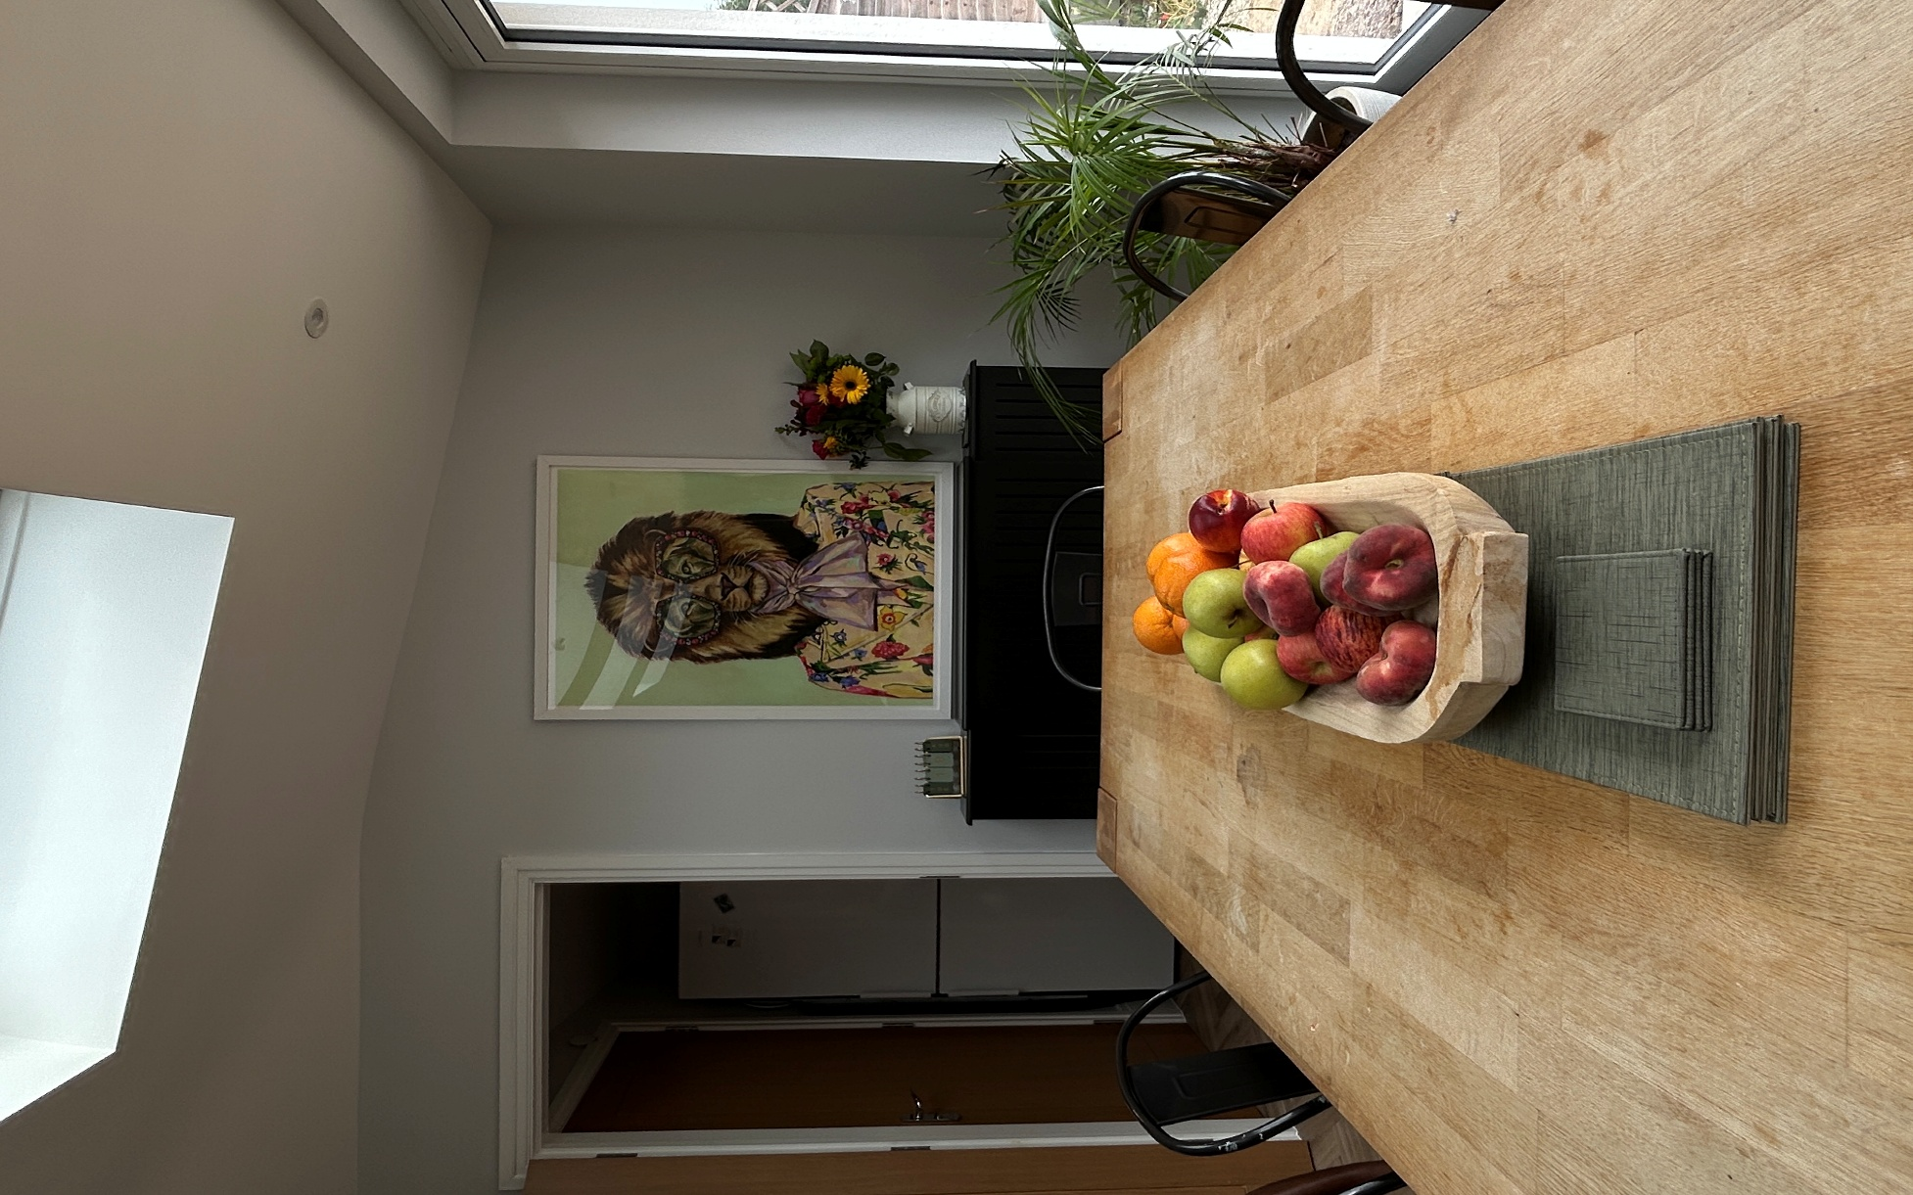

Independence

For young people leaving care, independence and life skills are like a launch pad to adulthood. These skills, from cooking to learning to drive empower young people to manage their own lives and boost their wellbeing. Having good

independence and life skills increase all types of opportunities in life for positive outcomes. Ultimately, these skills are essential tools for navigating adulthood with resilience and achieving their full potential.

At our home we prioritise fostering independence and preparing young people for a successful transition to adulthood. Here's how we ensure a smooth and individualised journey:

Individualised Plans: We begin planning well in advance, tailoring a plan to each young person's unique needs, aspirations, and goals. Some young people take on aspects of independence far sooner than others, and we recognise that progress is not always linear.
- Collaborative Approach: We involve the young person, their parents (where appropriate), their social worker, personal advisor, and other relevant professionals in the planning process, ensuring everyone is invested in the young person's success.
- Life Skills Development: We aim to equip young people with essential life skills like budgeting, cooking, self-care, and navigating public services. This empowers them to manage daily tasks and build confidence.
- Education and Training: We actively support the young person's education or vocational training. This could involve helping them apply for programs, liaising with schools or colleges, or exploring career options that align with their interests.
- Engaging with the community: Our aim is to try and find young people a hobby, club or activity that will give them a shared interest with others, so they can find and engage with their community.
- Safe Housing Options: We work closely with others to explore safe and secure housing options for the young person after leaving care. This could involve a transition to supported living, independent living, or other arrangements with support networks.
- Financial Resources: We work with personal advisors to ensure that young person have access to any necessary financial resources or benefits they may be entitled to. We will involve helping them understand budgeting and managing personal finances.
- Ongoing Guidance: Even after they leave our care, we offer ongoing support and advice. This could involve regular check-ins, connecting them with community resources, and offering a listening ear as they navigate the challenges and triumphs of adulthood. Any ongoing contact between young people and staff will need to be formalised with the local authority.
This is a continuous process, and we strive to adapt and improve our planning strategies to best serve the needs of the young people in our care. Our goal is to empower them to reach their full potential and thrive as independent adults. When independence planning for young people, staff can draw upon some of the following resources and guides.
Care Leavers Survival Guide, 2023-2024 - designed by former children in care from Oxfordshire.
A practical guide for care leavers, October 2022 – The Children’s Commissioner
Building independence through planning for transition – NICE
Keep On Caring Supporting Young People from Care to Independence July 2016
Life Skills for Teens: How to Cook, Clean, Manage Money, Fix Your Car, Perform First Aid, and Just About Everything in Between.

3 A description of the accommodation offered by the children’s home

(a) How accommodation has been adapted to the needs of children cared for by the children’s home

Our home is a large, detached house that comprises of five good size bedrooms for young people, three of which have ensuite facilities, there are two lounge spaces, a dining room, a shared bathroom, a newly extended kitchen, an office, a WC, two staff bedrooms /office space and some storage spaces.

In line with creating a therapeutic environment we work extremely hard to ensure that the home is as homely as it can be and wherever possible, free from any institutional type features or signage. Whenever we are looking to re-decorate or freshen up areas of the home, we will always seek the opinions and involvement of the young people.

Each child is encouraged (often prior to admission) and able to decorate their bedrooms to their own taste to promote individuality. Each young person’s bedroom is fitted with a TV and plenty of storage space. Some of our children have a dressing table, computer table (and chair), bookcase, and vanity mirror – each child’s furniture also reflects their tastes and interests. Each of our young people are able to access a separate WIFI connection in their bedroom so we can place different limits for each person.

The external doors are set nightly as a safeguarding measure, with individual bedroom doors only set for the children who may require its usage to signal for support in the night or who may pose a risk to themselves or others. Children are made aware of this support function when they arrive, and system usage is reviewed periodically to make sure it’s only in place for the children who need it.

We have a good-sized garden and patio area and we make good use of this space, comprising of vegetable patches, seating area garden shed and swimming pool in the summer months. We always ensure that there is a good selection of garden games, although we encourage young people to use more open spaces for things like ball games or riding their bikes.

We have two home vehicles to take our children to various educational, recreational, and individual specific outings. These are cleaned regularly and checked for safe usage daily.

(b) The age range, number and sex of children for whom it is intended that accommodation is to be provided.

Our home can offer a home to five young people aged between 12-17 years and we offer places to both sexes. We are in close collaboration with our sister homes Mannor Farm and Garden House which supports children from 6-14 years old this allows referrals and pathway plans for young people that still require therapeutic residential support. This enables the children to continue receiving consistent care within wider Fairways community.

4 A description of the location of the home

Our home is situated in Portchester a small, mainly residential town in Hampshire near other big towns and located in between two major cities, Portsmouth and Southampton. The home is located on a main road and is discreetly nestled in between other neighbouring properties. The proximity to the major cities ensures that we have access to city-based undertakings, leisure activities, educational and career opportunities. We also have easy access to many beaches & seaside areas, and we are at the foothills of the Southdown’s.

5 Supporting the cultural, linguistic and religious needs of children

Our home welcomes young people from all cultural backgrounds and can support them in holding and maintaining any religious beliefs and carrying out any spiritual practices if they wish to. The wishes of the children’s family in respect of their cultural/religious needs are, of course, taken into consideration. The home holds the view that discrimination is unacceptable, and young people are expected to actively demonstrate tolerance, understanding and empathy for every individual. Care staff are expected to curious and to celebrate “differences” and actively support young people’s cultural, ethnic, linguistic, and religious needs as part of individual care.

We are situated very close to larger urban communities of Portsmouth and Southampton which have very diverse communities and access to specialist foods, hair and skin care facilities, religious and cultural centres as well as a wide range of cultural events. If required, we are able to support a child attending a place of worship of their choice within the local community. Staff will also respect the child’s right to having a lack of faith.

6 Details of who to contact if a person has a complaint about the home and how that person can access the home’s complaints policy

We recognise the importance of a young person’s right to comment on or complain about any aspect of their care, the home, the staff or daily issues. Also, those representatives, relatives, and other significant people who may wish to complain, have access to the same procedure that is provided upon admission. On admission, children, their family and placing authority will be provided with information on how to complain, which will include a copy of the home’s complaints procedure.

A complaint is a written or oral expression of dissatisfaction or disquiet in relation to concern about the quality or appropriateness of services, delay in decision making about services, about delivery or non-delivery of services or about a disputed decision.

We have based our procedure on the principles listed below:

The central principles for our complaint’s procedure are:
- The welfare of the young person is paramount.
- Any concern about the quality of care must be fully explored.
- Investigations should be thorough, timely and consistent.
- All parties should be treated with dignity and respect.
- All adults and young people will be supported and treated fairly.
- Adults will have an opportunity to respond to any concerns raised about them.
- Confidentiality needs to be upheld throughout.
- All forms of complaints will be logged in a central register.

Any complaint will be addressed seriously and without delay. A complaint will be fully responded to within a maximum of 28 days and children, parents and the placing authority are kept informed of the progress. We recognise that any failure to respond promptly and sympathetically to a complaint in its early stages can sometimes lead to serious problems at a later date.
In most circumstances we will always try and resolve any complaints on an informal level with the Registered Manager (Unless the complaint is against them, in which case it is dealt with by the Responsible Individual) in the hope that they can be resolved as quickly as possible, reducing anxiety to the young person. Many complaints are an expression of dis-satisfaction and can be easily explored and remedied to the young person’s satisfaction. For those complaints that cannot be remedied by informal discussion, the young person will be given support to follow the process through to formal investigation and resolution.

All formal complaints are recorded and held on our electronic files within ClearCare. If young people have complaints about their social workers or local authority young people are supported to explore their rights on the https://www.childrenscommissioner.gov.uk/help-at-hand/ website and or make a complaint using their local authority’s online service.

Complaints by any party can be referred directly to OFSTED at any time. Their main office address is Piccadilly Gate, Store Street, Manchester M2 7LA. Telephone: 0300 123 1231.

It should be noted that this procedure does not replace child protection/safeguarding, grievance or disciplinary procedures, which can run concurrently with any action taken under the representations and complaints procedure.

Complaints policies can be requested from policies@fairways.co or by contacting the home management directly.

7 Details of how a person, body or organisation involved in the care or protection of a child can access the home’s child protection policies or the behaviour management policy.

 | Contact Number | Email Adress
Sharon Blackall, Registered Manager | 07936 959740 | Sharon.Blackall@fairways.co
Deputy Manager, Rebekah Lilly | 07394564260 | Rebekah.Lilly@fairways.co
Bret Noades, Head of Service & Responsible Individual | 07763 876 837 | Bret.Noades@fairways.co
Laura Rowe, Director of Residential and Family Services | 07823 344 410 | Laura.Rowe@fairways.co
Eileen Calnan, Designated Safeguarding Officer at Fair Ways | 07851251978 | Eilenn.Calnan@fairways.co
Hampshire LADO | 01962 876364 | Child.protection@hants.gov.uk
Hampshire Children’s Services | 01329 225379 | Childrens.services@hants.gov.uk
OFSTED | 0300 1231231 | Enquiries @ofsted.gov.uk

All the policies and procedures related to safeguarding and protecting children are available for all staff members in electronic version on the Access system. When new policies and procedures are created or have key updates, we share these with the team via our team meetings and internal communications systems.

Our designated Safeguarding Officer, Director of Residential and Family Services, Registered manager and Responsible Individual are responsible for the co-ordination of all aspects of safeguarding policies and procedures and ensuring that staff and young people are familiar with those that apply to them. All staff in the home are expected to always adhere to these policies, and report immediately if they are being breached in any way. In order for effective safeguarding of young people to take place then it is imperative that these policies are looked at collectively. Safeguarding, Whistleblowing, Behaviour management, E-Safety, Data Protection, Duty of Candor, Complaints, Allegations and Disclosure policies can all be requested from policies@fairways.co or by contacting the home management directly. These policies listed above are just some of the core documents that guide the way we work, safeguarding the young people is however covered in many other policies and procedures and guides most of the decisions we make about the home.

Young people in the home have a right to and must be enabled by staff to feel safe and be safe. They will also likely need support to understand how to protect themselves, feel protected and be protected from significant harm. In order to achieve this, we strive to place the utmost importance on adhering to our therapeutic ethos which places a strong value on making positive relationships with the young people. This generates a culture of openness and trust, and this also ensures that staff remain alert and aware of any signs, which may be subtle, that might indicate a young person is in any way at risk of harm. This should develop an ethos that encourages young people to feel confident about themselves and be able to tell someone they trust about any concerns or worries they may have.

We recognise that the previous life experiences of young people living in care may make them more susceptible to risk factors in the community. When they are placed in care, they should receive support and protection from potential harm and receive the best possible standards of care available to them. Safeguarding children living in children’s homes can be particularly challenging and requires those caring for them to be aware of the need to provide robust protection and to know what action to take if a child has suffered or is likely to have suffered significant harm.

Should a child disclose information of any abuse towards them, the Home Manager must be notified immediately. We are governed by legislation and mandatory practice when responding to child protection issues under the

Children Act (1989) amended (2004) setting out organisational responsibilities to safeguard and promote the welfare of children across all sectors. Fair Ways will also follow the Department of Health Working Together to Safeguard Children (2015) guidance.

Bullying We see bullying as an infringement of a person’s human rights, whilst understanding that bullying behaviours may have become learnt through our young people’s previous life experiences, staff promote, and role model a kind and caring environment to live in. Regardless of the motivators behind bullying, under no circumstances is it tolerated at our home. We are proactive in our approach towards bullying with our attempts to foster positive relationships in the home and address incidents immediately. In order to educate our young people and prevent episodes of bullying, they are expected to discuss and sign our anti-bullying protocol soon after arrival. We have adjusted this a few times over the years, involving the young people in the decision about how we do so via our community meetings.

If there are any incidents of bullying, we expect staff to do the following:
-Report incidents of bullying to their Line Manager/Senior and ensure that all incidents of bullying are recorded.
-Work with our Young People in a way that enables/empowers them to speak up about and hidden bullying behaviours.
-Use a restorative approach to work with Young People who demonstrate bullying behaviours to enable and encourage them to alter their behaviour.
-Take time to be with Young People who have been the victims of bullying.
-Work with and support Young People to enable them to report serious incidents to the police.

We operate with high staffing in the home and so this provides extra vigilance around any bullying or intimidation. Staff discuss these incidents in debriefs and ensure any concerns or suspicions of bullying are handed over to other staff members, discussions around bullying are also held within staff team meetings.

Radicalisation
Our aim is for adults to be trained in the prevention of radicalisation and is committed to actively promoting the spiritual, moral, social, and cultural development of children in line with British values. The adults are trained to spot signs of behaviour, which undermine British values and have clear pathways to report any such behaviour through the channel process. We recognise the risks to children and children around radicalisation and have developed a policy which outlines how the organisation will minimise those risks for the children we support.

CSE
Looked-after children may also be particularly vulnerable to sexual exploitation by adults in the community. The NSPCC defines sexual exploitation as ‘being when someone grooms and controls a child for a sexual purpose’. The term ‘child sexual exploitation’ is used to refer to a range of illegal and abusive activities that can broadly be separated into two areas:

• Sexual exploitation through street grooming
• Online sexual exploitation.

Where child sexual exploitation or the risk of it is suspected, residential care adults must discuss the concerns with the home manager or the designated member of adults for child protection within their service. If after discussion there remain concerns, local safeguarding procedures must be triggered, including referral to local authority children’s social care and the police.

The support needs of the child concerned, including how they will be kept safe from intimidation and future exploitation, should also be discussed with statutory agencies and a joint plan of action agreed upon. We will use the CSE screening tool as part of the initial induction into the home for the children.

Missing Child
It is explained to all children on admission, in language appropriate to their age and ability, that if they are away from the home without permission the adults will be worried as to their whereabouts and safety and will have to take action to locate them and return them home. The home has an agreed Missing Person’s protocol with the local police, and each child will have their own risk assessment for being absent from the home without leave.

The procedures when a child goes missing are as follows:
• The house and grounds are first thoroughly checked.
• The local area is searched after five minutes.
• Within 30 minutes (depending on the individual risk assessment) the Police are contacted to report the child missing or unauthorised absence. A full description of the child and the clothes they were wearing is given and the photo from their file used.
• The Registered Manager or on call manager is informed as are the other local homes.

If there is any doubt regarding the safety of any child, the police will be notified immediately. Case holders and parents / carers are notified as soon as possible – dependent on wishes (some parents choose not to be informed during the night).
It is important that plans are made for the return of a child. Adult numbers and planning should reflect the need to engage and support the child who may return in a negative frame of mind. Adults should always discuss the reasons for the non-return, the child’s whereabouts and who they were with at an appropriate time following their return; this is all completed on a return interview with the child.

Views, wishes and feelings

8 A description of the children’s homes’ approach to consulting children about the quality of their care

As part of the homes aims to be therapeutically minded, we have moved away from having young people directly involved in documents like risk assessments, behaviour management plans as these are often very shame inducting documents to read over for young people. Instead, we discuss and key changes with them, aiming to do this together but keeping in mind that safeguarding is the key principle. More than anything else the way we get the young people’s views on everything, is by having a relationship with them and speaking to them. Of all the procedures below, most of these are just variations of conversations.

Community Meetings - The structure of these meetings tends to contain certain agenda items in relation to practical parts of running the home like the shopping list, activities requested by the young people and what improvements they would like to see happen in the home. We can update the young people about any new staff or young people that may be joining the home. The meeting has a weekly topic which can range from topical events happening in the world, holding honest conversations, bike safety, how to make a complaint, to internet safety. We have had and will continue to invite visitors on occasion including the local Policing teams, sexual health advisor’s independent visitors. These meetings function as a positive way of discussing and resolving any group conflict or disruptions in the home. Most of the requests that the young people make never even make it to the community meeting and are decided with keyworkers and the management team.

Day to day, keyworker sessions and significant conversations - We record these conversations on our ClearCare system for a number of reasons, firstly these so that the young people have a record of their care and time with us and also to keep the rest of the team up to date with what is currently happening in the young people’s lives. We have recognised over the years that staff in children’s homes can often inadvertently seem to over remind the young people, simply by a few staff members unknowingly having the same conversations, this is due to the set up being so different from a family home, or foster environment. Recording these conversations reduces the likelihood that the team will accidentally come across as nagging the young people. Safeguarding the young people often involves some of the key details about things that they are speaking with us about. Having a record of these allows us to spot trends and be able to look back over time.

Core group meetings we ask that keyworkers aim to have a formal catch-up meeting with the young people once per month that aims to discuss a variety of topics, as well as try to engage the young people with the homes reward-based procedures. We have found that these meetings are an effective way to involve young people in working towards positive outcomes for themselves. We can also use these as an opportunity to possibly discuss more serious or often shame inducing topics, that we can then not directly discuss with the young people for some time if possible. As these meetings can often be difficult to engage with, we offer a small reward for doing so after the meeting or hold the chat somewhere that the young people chose.

Meetings Young people are always invited to attend any meetings which are pertinent to them, or we aim get their wishes & views to be shared by us if they do not wish to do so in person. Their will often be times and occasions when young people are not invited to certain meetings or parts of meetings, and we will remind them that it is perfectly normal for adults that care for young people to have discussions about their care in private. Upon admission and periodically we remind the young about their right to be able to speak with an advocate and encourage them to speak with our independent visitor.

Team around the young person we aim to ensure that young people are regularly meeting with their social worker and have the opportunity to meet with their independent reviewing officer.

Bi-annual feedback forms These take account of young people’s views, thoughts and wishes in relation to safety, the home, rules, boundaries, family, local authority, education, leisure, hobbies, friends, and much more. These allow us to be able to track the way the young people feel about certain aspects of their care and the home. Over time we have been able to see changes and positive improvements about the way which care is provided.

A description of the home’s policy and approach in relation to Anti-discriminatory practice in respect of children and their families; and Children’s rights

Positive adult role models are considered of the utmost importance in demonstrating kindness, respect, and fairness towards everybody. Young people are encouraged by this example to address any aspect of discrimination within the home. Our home is a place which promotes and values diversity and equal opportunities. We are committed to promoting a positive and diverse culture in which all children and staff are valued and supported to fulfil their potential irrespective of their age, disability, race, religion, belief, sex, or sexual orientation. All young people and their families are treated with respect and accorded the maximum privacy, personal choice, and autonomy within the overall requirements for safety.

At our home, we aim to increase young people’s self-worth and self-esteem, to develop respect for themselves and others, understand their rights and know how to about challenge discrimination. Young people will be cared for by staff who have been suitably trained in all aspects of equality and diversity including legislation and their responsibilities around this.

Fair Ways is committed to practices that uphold the principles of the following:
• Children Act 1989
• Children Act 2004
• Community Care Act 1990
• Care Standards Act 2000
• Disabilities Discrimination Act 1995
• Sex Discrimination Act 1975/1986
• Race Relations Act 1976
• Human Rights Act 1998
• United Nations Convention on the Rights of the Child (Article 12)
• National Standards for the Provision of Children’s Advocacy Services 2003
• Children’s Homes Regulations including the Quality Standards (2015)

If you would like information on the rights of a child:
https://www.gov.uk/government/publications/united-nations-convention-on-the-rights-of-the-child-uncrc-how-legislation-underpins-implementation-in-england

Education

Arrangements for young people to attend local schools, promoting educational achievement and supporting young people with special educational needs

We place great emphasis on education and on supporting young people to achieve in this vitally key area. All young people must have a Personal Education Plan to help everyone gain a clear and shared understanding about the way in which to support the young people best.

If due to negative experiences, there is a complete breakdown of trust or felt safety and if a young person is unable to go to school, the team work with the local authority, virtual head and SEN teams to arrange for some alternative provision or options. During this time the aim should be to work towards a time when young people may be able to renter a school, college, special provision, other training or employment.

We aim wherever possible to have young people within schools that are local to the home, there may be instances where for the sake of consistency young people may travel some distance for their education, this will always be in conjunction with their wishes and if long travel becomes an issue, we will look for an alternative arrangement.

We recognise that for various reasons it is not always possible for children to attend mainstream education such as severe trauma, social, emotional, behavioural or learning difficulties. Children may have been out of education for long periods of time and may struggle to integrate into the mainstream classroom. For those children that meet the age and educational requirements, Fair Ways has three of its own DfES registered schools including an education centre for special needs pupils aged between 11-19 years old.

All our educational packages are tailored around the needs and abilities of the individual child and can be discussed with our placements manager upon request to the management team.

We will also work with The Virtual Head who is responsible for promoting the educational achievements of looked after children, regardless of where they are placed. This ensures the best quality education and training to meet the needs and aspirations of young people in care and equip them with the qualifications and skills needed to progress and participate fully in society.

Young people at our home often have a wide range of special educational needs including learning, emotional and/or behavioural difficulties that require a special educational provision
to ensure each young person achieves their learning potential. Other forms of need that may be undiagnosed e.g. dyslexia, dyscalculia, speech and language difficulties or specific difficulties such as those arising from autism or attention deficit disorder if not able to be assessed in school, can often be assessed by the Fair Ways Hub team.

We encourage young people to realise the importance of education and understand the benefit that formal education and qualifications can play later in their life. We often include positive engagement and or attendance within the young people’s target and reward systems to encourage this further.

The team in our homework in partnership with the education staff and Local Authorities to support children with Special Educational needs as identified through their Education Health Care Plans, IEP’s, PEP meetings, and CLA Reviews. We aim to act as advocates on behalf of our children and support attainment, admissions, attendance, or conduct, as a typical parent would do. We have a positive holistic view of education looking at non-traditional and enjoyable learning opportunities to promote learning within and outside of the home setting.

As our young people are approaching the age at which they may want to seek part time employment or an apprenticeship scheme we are able to support them to think about the skills or knowledge they may need. We will support with CV writing skills, and we can offer young people the opportunity to have a ‘mock job interview’ with our recruitment teams within Fair Ways head office. This allows young people to gain some practice going into a big unknown environment and spending some time talking about themselves with people that they don’t know. This can replicate the feeling of going for an interview, but without the added pressure of a potential rejection for a job.

We encourage and invite the school to attend our TAC meetings (see Care Planning), so that all professionals directly involved in the childcare can have the opportunity to meet and discuss most current developments and supportive strategies. We also include the educational facilitators in the homes weekly update reports.

Enjoyment and achievement

11 The arrangement for enabling children to take part in and benefit from a variety of activities that meet their needs and develop and reflect their creative, intellectual, physical and social interests and skills

All Young People at Portchester Road are given the opportunity and support to continue any hobbies or activities they currently have when they arrive or to try out any new hobbies that are of interest. Activities are recognised as an important opportunity for our young people in meeting social and developmental needs including self-esteem and we
encourage these in and outside of the Home.

Weekly community meetings allow our Young People to discuss their preferences and to make a weekly plan of activities. The staff team plan a range of recreational activities with Young People as part of daily living and we have certain activities in the home like quiz nights, movie nights, takeaways, swimming and other cultural celebrations.

As our young people work towards independence, we look to find hobbies and activities that are easily accessible during transition to adulthood. We recognise that having a passion or an interest is a way in which our young people can meet other young people and build relationships.

We aim to organise activities that sit outside of the young people comfort zones, recognising that this is the area where people learn and grow. We will try to take a gradual task exposure stance towards this, and we recognise that every young person has the right of self-determination and choice, and we will never force a young person to do any activity that they do not wish to do.

We try to ensure that the young people are always planning or have arrangements in place for big days out and special activities/events, so they have something to look forward to. Primarily these tend to fit around school holidays and sometimes weekends, these include trips to theme parks, music concerts, festivals, sports events, outdoor adventure activities and weekends or breaks away from the home.

Young people at our home are only limited by their imagination in terms of what activities, hobbies or pursuits they may wish to try. We feel we are able to accommodate or offer almost anything and will try our hardest to do so.

Our staff team understand how young people in care can easily become isolated from the local community. We actively encourage our young people be involved in our local community, understanding the importance and impact it can have on their future independence. By understanding the individual needs of the Young Person, we are able to work with groups that are appropriate to them.

We encourage all young people to learn to drive while they are with us and will support young people with their theory driving exams. We have in the past had many young people take up this offer and we recognise that having the ability to drive is a strong aspect of employability and creates opportunities for work.

Health

12 Details of any healthcare or therapy provided and qualifications of the involve in providing this

When our young people come to our home, we ensure that they are registered with a local GP, Dentist & Opticians who will deal with both routine and emergency treatments, they will also receive an annual health review with the local LAC Nurse. Our home has Individual Health Plans in place to record health related concerns and track all medical issues and appointments ensuring that optical and dental treatment is provided, and health needs are met. A written record is kept of all doctors, optician and dental appointments with any treatment, prescribed medicines and any follow-up advice documented – which in turn could become part of the child’s Placement Plan.

Young People are supported and encouraged to take ownership over their own health needs and make informed decisions on their health. This includes being aware of what support is available to them, young people with special medical needs are encouraged and supported to attend specialist clinics e.g. ADHD, asthma, severe allergies, epilepsy, hearing etc. in order to promote positive health care. We encourage the older young people in our home to develop their independence by making their own medical appointments and attending these independently if appropriate.

Medication and other treatments are not given without a young person’s consent or/and the consent of those with parental responsibility. All medicines are kept in a locked room and locked in the medical cabinet however we aim for young people to work towards self-administrating their own medication in line with their independence and care plan with the aim of supporting moving forward.

The staff team have an important role in the health education of our young people at our home. We provide young people with guidance, advice and support appropriate to their age, needs, culture and wishes in relation to health issues. This may include alcohol and substance misuse, smoking, sex education and sexual health. They are also taught about the benefits to their health of good nutrition and diet, adequate exercise, sleep and personal hygiene.

Our team encourage the young people to be as physically active as possible day to day, offering more formal types of structured exercise where possible. Once our young people reach 14 years of age, we offer them the ability to have gym memberships locally and we have at times invited personal trainers into the home for group workout sessions. We have some simple physical exercise equipment available in the home that the young people can use.

Clinical and Therapeutic Team

The (Hub) clinical and therapeutic department is a multi-disciplinary therapeutic service central to all other Fair Ways services. The Hub works primarily with Fair Ways services to

ensure children’s emotional, social, and educational needs are identified through effective screening and clinical assessment. The Hub team work with Fair Ways staff through supervisions and training to ensure young people receive the most appropriate support and evidence-based interventions to help meet their needs. The Hub will deliver specific, time-limited evidence-based interventions where appropriate following a comprehensive clinical assessment.

The Fair Ways Clinical Hub also works with local mainstream and specialist services including wider professional networks to ensure seamless pathways for care and treatment and to help identify appropriate thresholds between The Hub and Community CAMHS. If a child presents in mental health crisis, the role of The Hub is to ensure the Fair Ways staff team seeks emergency treatment for the young person through the appropriate physical and mental health services. The Hub does not act as an emergency service and Fair Ways staff will be supported and educated on appropriate care.
pathways in the case of an emergency.

The Fair Ways Hub supports the following:
• Children’s therapeutic needs assessment
• Sensory profile assessments
• Cognitive assessments
• Direct 1:1 therapy or dyadic therapy
• Group reflective supervision and management reflective supervisions
• Staff training in a range of specific subject areas
• Attendance at meetings in relation to young people

Access to specific external assessments as required (e.g. Educational Psychologist)

Assessment

Assessment starts from the initial referral and admission planning. Within first 3-6 months of the child’s placement the clinician assigned to Portchester Road creates the assessment of the therapeutic needs. The assessment is systemic and draws on previous assessment and information from previous schools and placements, observations from the adult’s team and TAC meetings reports and discussions.
Chaired by the clinician, TAC meetings take place every two months for each child and are the main forum for the formulation of therapeutic interventions. They represent ongoing process reviewing and assessing of the child’s developmental needs and effectiveness of our therapeutic interventions.

Individual therapy

The specific individual therapy may be delivered or sourced externally by the clinical hub should the need for such intervention be identified in the process of assessment the child’s therapeutic needs or arises at any stage of the child’s placement.

Outcome Measures

• Focus on qualitative data from key workers reports, key work sessions, TAC reports and discussions.
• Quantitative data from management reports including the longitudinal trends in the use of RPI, Incidents, Consequences, and rewards
• Internal Placement Plan designed to track changes of the child’s developmental needs through 6 monthly assessments of the progress against the baseline (the child’s needs on admission)

Adult Consultation, Supervision and Dynamics

Clinician attends team meetings to provide the adults with the opportunity to explore the themes from day-to-day support of the individual children, the dynamics of the group, and interventions. This form of reflective supervision is one of the core elements of the homes practice.
The management team are available throughout the week to provide the team with ad hoc reflective supervision. The scope of these may be to look at, explore, and, if possible, address and resolve any challenges the team are facing.
The Responsible Individual carries out yearly consultation with all adults in the form of anonymous survey on various aspects of the home performance. The outcomes of the survey are shared with management.
The hub may also offer individual clinical supervision to adults where either they or their manager identifies an additional support need.

Positive relationships

13 The arrangements for promoting contact between children and their family and friends.

We recognise that nurturing and maintaining meaningful connections with family and friends is essential to a young person’s sense of identity and emotional healing. At our home, we collaborate with young people during the admission process to co-create contact arrangements that feel safe, supportive, and attuned to their individual needs. We warmly welcome loved ones into our home, actively encouraging a sense of belonging and community.

A young person’s voice is central to their relational journey. we remain deeply sensitive to their wishes and feelings, acting as tireless advocates should they wish to evolve their contact arrangements. We believe that connection is a fundamental right, not a privilege; therefore, family time is never used as a reward or a consequence. We honor the young person’s autonomy by never forcing attendance at visits, ensuring they feel in control of their emotional boundaries.

To help us understand and support each child’s emotional journey, we use Clear Care to reflectively record their experiences. Rather than simple monitoring, this allows us to notice patterns in their mood and presentation before, during, and after contact. By doing so, we can provide the necessary co-regulation and emotional scaffolding to help them process complex feelings, sharing any significant insights with their Registered Manager and social worker to ensure their care plan remains responsive.

We protect the sanctity of a young person’s support network. Meetings with social workers, legal advisers, advocates, and independent visitors are unrestricted and held in private, providing a safe space for their rights and voices to be upheld. We sensitively document these moments to ensure consistency in their support and to remain attuned to their emotional well-being throughout the process.
We empower our young people to cultivate healthy peer relationships within the community and at home. Through thoughtful risk-awareness and facilitated activities, we help them navigate social experiences safely. We encourage regular connection with the outside world through after-school and evening telephone calls, providing the tools and space they need to maintain the "golden threads" of friendship and family life.

Protection of children

14 A description of the children’s home’s approach to the surveillance and monitoring of children.

Day to day supervision of our young people is paramount, however we recognise that adolescent young people require certain freedoms both within and outside of the home. As established elsewhere in this document, the keyway we can protect our young people is by knowing them well and having a relationship with them. Knowing them allows us to spot patterns in their behaviour so we can notice change, and the relationship will promote honesty and allow us to speak with them when we have concerns.

Within the home, we utilise an electronic door alarm system during nighttime hours, and these are fitted to young people’s doors and exterior doors. The purpose of this system is to help monitor and safeguard all young people. All young people’s bedrooms, and exterior doors are fitted with sensors. This alerts us when a door is opened and/or closed, which discreetly notifies the team when young people are up in the night, or if they leave the home. We are able to isolate certain bedroom doors, and the use of each door alarm is risk assessed case by case and regularly reviewed. All the young people and placing authorities are made aware of any sensors that are installed when they visit the home, and prior to being placed. We request that Social Workers also sign a consent/acknowledgement form to state they are happy for this alarm system to be used to ensure safety of all parties.

Night-time arrangements ensure children have immediate relational support while preserving dignity and predictability. Night-time supervision is delivered through two staff on duty between 23:00 and 07:30 - one waking night support worker and one sleep-in staff member. This structure ensures that children have immediate access to support during the night whilst maintaining consistent safety and reassurance. Where required, the home can temporarily operate with two sleep-in staff to maintain safety if waking night cover is unavailable.

Within the home, there is an inbuilt electronic security system that monitors the home’s internet use and web-based activity. This is called Draytek Content filtering, and it helps to filter out and block inappropriate content, such as websites with sexual, violent, or other adult-oriented content on the children’s computers. The young people are made aware of these internet restrictions and safety measures via the homes in house mobile and device usage contracts.

We may search the young people’s bedrooms if we believe that they may have anything illegal or dangerous. We will always aim to gather consent from the young people prior to do so if the situation allows. Any electronic device searches will be agreed with the social worker, and a plan will be drawn up to establish the specifics of this.

15 Details of the home’s approach to behavioural support, including the home’s approach to restraint in relation to children and how staff are trained & assessed

Positive behaviour and respectful relationships are actively modelled, reinforced, praised, and encouraged at Portchester Road. When behaviour becomes unsafe or falls below expectations, staff respond promptly and proportionately through calm, restorative conversations that help young people understand impact, repair relationships, and build safer choices. The development of safe, stable, and secure relationships with trusted adults is central to the ethos of the home and supports the development of secure attachments that, where appropriate, can be sustained over time.

One of the most effective ways the home promotes positive behaviour is through the consistent and thoughtful use of rewards, relationships and recognition. Rewards and praise are an important part of our behaviour support and are designed to strengthen positive choices in both the short and long term. The home is quick to notice, acknowledge, reward, and celebrate when young people manage their behaviour well, particularly in challenging situations. We understand that developmental trauma can affect a young person’s ability to accept and enjoy praise, so we tailor our approach with sensitivity and patience.

Some young people in our home may have experienced early adversity, including trauma and inconsistent caregiving. These experiences can affect how safe it feels to trust adults and can make forming and maintaining positive relationships more difficult at times. Our staff respond with warmth, curiosity, and consistency, helping young people develop self-worth, confidence, and the skills needed to communicate feelings and needs safely. Over time, this supportive approach can reduce behaviours of concern and strengthen a young person’s sense of belonging and stability.

At our home, staff maintain safe, consistent, and clearly explained boundaries that help young people feel secure and understand what is expected. Staff follow agreed house consistencies and the personal consistencies that are specific to each young person. Many situations can be de-escalated and resolved through early, low-level support such as gentle reminders, coaching, and reflective conversations. Where repeated support and requests have not been effective, formal consequences may be considered as a structured learning opportunity.

Where formal consequences are used, they will be fair, proportionate, and the minimum necessary to support learning, restore safety, and achieve a positive outcome.

If a consequence is required, staff will apply the following principles:

- Take the young person’s age, understanding and capability into consideration.
- Consequences will often require a discussion with the team, don’t make this decision in the moment.
- Consequences should only last as long as they need to and allow the young person the opportunity to make a fresh start as quickly as possible.
- If there is a natural consequence of this, a reflective conversation may suffice.
- Consequences should always be related to the behaviour.
- The consequence must always be reasonable and if it can be implemented effectively.

We ensure that all staff are aware of the acceptable measures in relation to consequences and supporting positive behaviour, a lot of this is a big part of our RiiSE training. Staff will be made aware of the Supporting Behaviours of Concern Policy for a full list of acceptable and unacceptable consequences.

Formal consequences may include a temporary loss of an activity, a proportionate reduction in some pocket money, a pause on use of the car, or a temporary restriction of Wi-Fi, and will always be linked to the behaviour and clearly explained. Where appropriate, reparation tasks may include tidying a mess that has been made or supporting the repair of items that have been damaged. Reflective conversations are central to our approach; when young people are supported to talk through what happened, explore feelings, and identify different choices for next time, they can strengthen their sense of agency and their belief that positive change is possible.

We recognise that actions often lead to natural outcomes, and sometimes the most helpful response is a supportive conversation that helps a young person reflect and learn. Natural outcomes may include damage to personal property, difficulties with peers, or being late for school; staff will use these moments to build insight, repair relationships where needed, and plan for success next time.

The home will ensure that Individual Support Plans are kept live that are specific to the young people whilst also being dynamic and updated when we learn past incidents.
The principles relating to the use of Physical Intervention may be summarised as follows:
- Staff should take all possible steps in advance to avoid the need for physical intervention, and the young person will be warned prior to the intervention.
- Only use the minimum force necessary when physically holding a young person.
- As soon as it is safe, physical intervention should be gradually relaxed to allow the child to regain self-control, we never seek to hold young people until they are ‘calm’.
- Physical Intervention should be an act of care and support in efforts to secure safety.

RiiSE

In March 2022, Fair Ways introduced a new training programme, RiiSE (Relationship Inspired Ideas for Supportive Environments). RiiSE is certificated by BILD (British Institute of Learning Disabilities) and aligned to RRN (Restraint Reduction Network) Training Standards. Within the home, all core staff complete RiiSE as part of their induction. The programme strengthens understanding of behaviour that challenges, promotes effective de-escalation, and supports the safe use of physical restraint only as a last resort.

RiiSE is informed by established research and practice in trauma-informed care, attachment, and neurodevelopment, drawing on the work of a range of leading practitioners and researchers. This evidence base supports our understanding of how trauma and adversity can affect the young people and adults we support. The programme promotes a culture of safety, security, and trust, with positive relationships at the centre of everyday practice. It also incorporates key frameworks, including our ‘House Model of Parenting’.

RiiSE provides practical, preventative de-escalation approaches and therapeutic strategies grounded in a supportive, relationship-based philosophy. The associated physical intervention techniques were developed to be rights-respecting and are used only when necessary. Each technique is risk assessed against the following criteria:
• Risk of psychological or emotional harm, including re-traumatisation
• Whether the technique compromises the person’s dignity
• Any potential for pain compliance or the intentional infliction of pain as a means of control
• Any involvement of sensitive areas of the body (e.g., neck, chest, or intimate areas)

Staff are assessed throughout the five-day course. This includes ongoing observation of attitude, de-escalation skills, and practice aimed at preventing the need for physical intervention, alongside assessment of trauma-informed knowledge on day five. Competence is confirmed through direct observation and an end-of-course knowledge test. A two-day refresher is completed annually, and RiiSE coaches across the organisation can provide additional refresher input within homes and teams as required.

The principles for the use of physical intervention are summarised below:

• Staff must reasonably believe immediate action is necessary to prevent significant injury to the child or others.
• Wherever possible, staff should take proactive steps to avoid the need for physical intervention (e.g., through dialogue, distraction, and diversion). The child should be given a clear verbal warning that physical intervention will be used if they do not stop.
• Any intervention must use the minimum reasonable force for the shortest time necessary to prevent injury or serious damage.
• Where practicable, staff should seek the presence of another adult before intervening. Other adults can support the intervention and act as witnesses.
• As soon as it is safe, staff should reduce and release the intervention gradually to support the child to regain self-control.
• Physical intervention must be an act of care and support, never a punishment.
Accurate records must be completed for all incidents involving physical intervention. Incidents must be reported to management and shared with other relevant professionals, as appropriate. A record of the intervention must also be saved in the child’s file on ClearCare.
Following an appropriate period of time, the child’s key worker should meet with the child privately to discuss what happened and explore how similar situations might be avoided in future (re-Attunement). A summary of any physical intervention is sent to the child’s social worker on a weekly basis.

Monitoring of behaviour and incidents

The Registered Manager & Deputy Manager monitor all incidents of behaviour support, and restraint (all incidents of physical restraint are also reviewed by the lead RIISE coach within Fair Ways) to ensure that actions taken by the team were effective and that young people are correctly supported. We can also use this information to identify trends and patterns that will assist with improving practice. The information from the analysis helps to inform our care planning, risk assessing and individual behaviour support plans. We will notify key professionals and possibly parents of incidents via the homes weekly reporting processes. More serious incidents will be reported soon afterwards via email.

Supporting Behaviours that Challenge and Restrictive Physical Intervention policies can be requested from policies@fairways.co or by contacting the home management directly.

Leadership and management

Head of Residential Services: Bret Noads Bret.Noades@fairways.co

Registered Manager: Sharon Blackall Sharon.blackall@fairways.co

Director of Residential & Laura Rowe Laura.rowe@fairways.co Family Services

Company address: Portchester Road
Fair Ways, 75 Portchester Road
Ground Floor, Building 1000, Porchester
Western Road PO16 8NS
Portsmouth 01329286781
PO6 3EN.
02380 230400

- Details of the management and staffing structure of the home, including arrangements for the professional supervision of staff, including staff that provide education or health care.

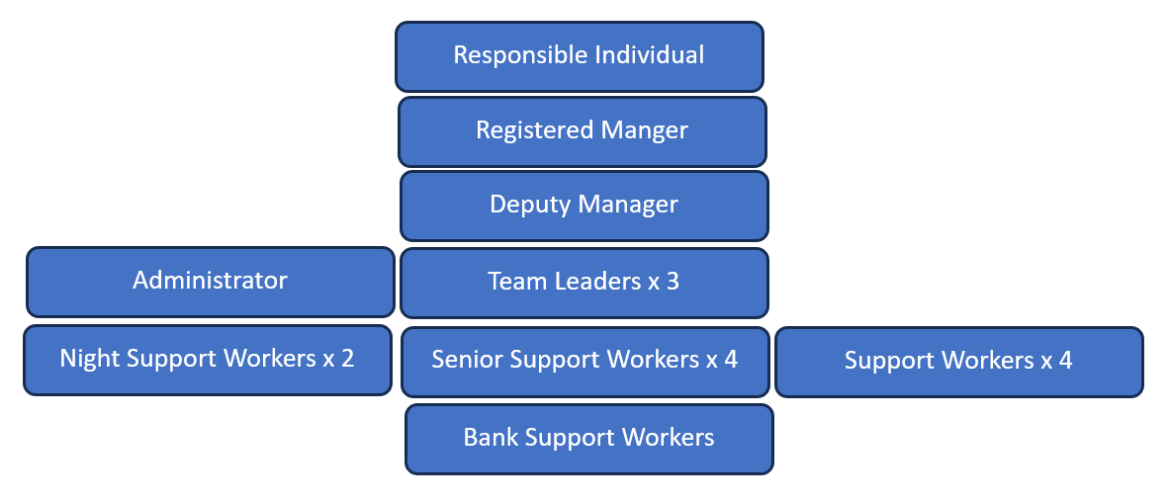

All staff receive regular supervisions with their Team Leader to discuss performance, key-working responsibilities, the needs of the young people, and to reflect on any incidents and safeguarding concerns. Supervision is regarded as a valuable, two-way process that supports continuous development. The full team attends monthly reflective group supervision facilitated by a clinician from our Clinical Hub team

Occupancy | Minimum Ratio’s | Preferred ratio | Night staffing levels
1 | 2 | 2 | 1 waking night and 1 sleeping staff member.  Or  2 sleeping staff members.
2 | 2 | 2
3 | 2 | 3
4 | 3 | 4
5 | 3/4 | 4/5

Our staff team all work on a shift pattern of 2 on 4 and our staffing ratios can be seen above. Our rota is set up so that there should always be a team leader working, apart from when they are away on leave. In those instances, we have some very experienced senior support workers who are able to lead the home day to day.

All staff receive an annual appraisal with their line manager. This process tracks their development and forms part of their Personal and Professional Development Plan – which should be used at a point of reference within supervision sessions.

During the probationary period of new staff to the role, we offer supervision on a more regular basis for the initial six months. Our home is currently staffed with a wide range of staff from different ages, sexes and races and many different backgrounds. This is something that we really celebrate and see our mixture of cultures and experiences as a strength in our home.

Induction Training consists of relevant information and guides to ensure safe and appropriate onboarding, taking into consideration the needs of the role and recognition of prior learning. All new staff are required to complete specific online trainings within the first week of their employment. E.g. safeguarding children, medication, H&S, and fire prevention. Within the first months of employment new staff members are trained in RiiSE, Recording and Reporting, Manual Handling, Food Hygiene, First Aid, and Medication Competency.

Upon successful completion of the probation period the staff are require undertaking a Level 4 Diploma in Residential Childcare if it is not already held. Deputy Managers and Managers are required to complete the Level 5 Diploma in Leadership & Management.

Any staff member placed in charge of the home and other staff in supervisory roles such as shift leaders will have completed both their induction workbook, supervision training, and a shift leader competency check.

Deputy Managers and Registered Managers of our four residential children’s homes in the Solent area share on-call management duties (24/7), completing one in every eight weeks. This provides the homes with support and guidance when the management are not working in their homes.

Care planning

18 Any criteria used for the admission of children to the home, including any policies and procedures for emergency admission.

Admission Criteria
We consider admissions for children who require a stable, nurturing, and therapeutically informed residential placement. Admissions are based on child-centred assessments and multi-agency consultation, ensuring the home can meet each child's needs safely and effectively.

We will consider referrals for children who:
• Are preferably aged 12–17 at the time of referral.
• Present with complex social, emotional, or behavioural needs.
• Display harmful or developmentally inappropriate sexual behaviours.
•Exhibit challenging or conduct-related behaviours.
•Have mild to moderate learning needs or neurodiverse traits, including autistic traits.
• Have been excluded from mainstream education or require support to re-engage.
• Can live in a structured, therapeutic, relational group environment and build trust with adults.
• Are motivated to make positive changes in their lives.

We are unable to accommodate children who:

• Require continuous psychiatric supervision.
• Are currently addicted to hard drugs.
• Present persistent fire setting behaviour.
• Have profound physical disabilities or profound learning difficulties that cannot be safely supported.
• Pose a serious physical risk to others that cannot be safely managed within a group setting.

Referral and Admission Process

All referrals should be sent initially to the placements team via email on placements@fariways.co. The placements team will be screen these to ensure that these meet our admission criteria above and then sent on to the registered manager in the home for review.

The manager will carefully assess potential referrals to ensure that the home is able to effectively meet the child’s needs while ensuring that any impact on the current young people is not overtly detrimental. If this is believed to be the case, then we may begin our admission process. If at any stage of our admission process, new information comes to light that we were not initially aware of we may make the decision to pull our offer of a placement.

The first part of our process would be to hold a meeting with the social worker, and parents if appropriate to explore information already shared, and to give both parties an opportunity to seek any clarity needed. If this stage goes well the management team will provide the young person with a copy of our young people’s guide and then arrange to meet with them to discuss this. If they are willing, we would then invite them to come and see our home, their potential bedroom and to meet some of the staff and current young people. Meeting the staff and other children can diminish some of the anxiety they will understandably have about moving to another home and school. Where possible, a child’s parents/carers should also have the opportunity to be involved in this process.

Once the above meetings & visits are completed the home will be able to formally offer a placement for a young person. At this stage the management team will complete a preplacement impact assessment summarising all of the above stages and information that has been shared. We will also ask for some more information and further documentation and then agree up a transition plan with the young person. During this transition we will aim for the young person to join the home for activities, possibly a meal and we may send staff members to meet with the young person in their current home. Wherever possible we will try to involve young people in decorating their new bedroom and to join us in going shopping for new decorations and furnishings. Upon admission we will hold a placement planning meeting with the young person and their social worker.

Same Day Admissions

Our home does not currently offer same day referrals.

Ongoing Planning

As part of ongoing planning, placement review meetings must take place within statutory timescales, in accordance with the Placement Planning Regulations. The date of the first statutory review in placement will be agreed between the placing authority and the home at the time of admission. If this is not possible the IRO will be contacted and asked to set the LAC review date. Whilst it is the responsibility of the placing authority to initiate statutory reviews, the home will be pro-active in advocating on a child’s behalf where there is any delay.

It is the key workers responsibility to prepare a written report for the statutory review and to ascertain verbally, or in writing the young person’s views and wishes regarding their care. The key worker will ensure that they are fully prepared for the review, have a clear understanding of their role in the review process and will have facilitated the child being able to express their view or wishes.

The review process involves all professionals, the child, and relevant key members from their family. Key objectives and tasks are set within the planning forum to indicate work to be carried out on a range of criteria individual to the child.

Summary

Our overall aim is to provide a safe, nurturing environment in which the physical, social, intellectual, spiritual, and emotional development of every child is facilitated and differentiated according to need.

In responding to the individual needs of the young person, the home will at all times operate within the framework of the Children Act 1989, Children Act 2004, the Quality Standards (2015), the Children’s homes regulation (2015), The Social care common inspection framework (SCCIF) and Fair Ways’ childcare policies.

Porchester Road’s home’s operation will be evaluated regularly through Fair Ways’ Management via Regulation 44 visits and management schedules as detailed in Regulation 45, service purchasers and independent inspections through Ofsted.

Fair Ways, Building1000, Western Road, Portsmouth PO6 3EN.

