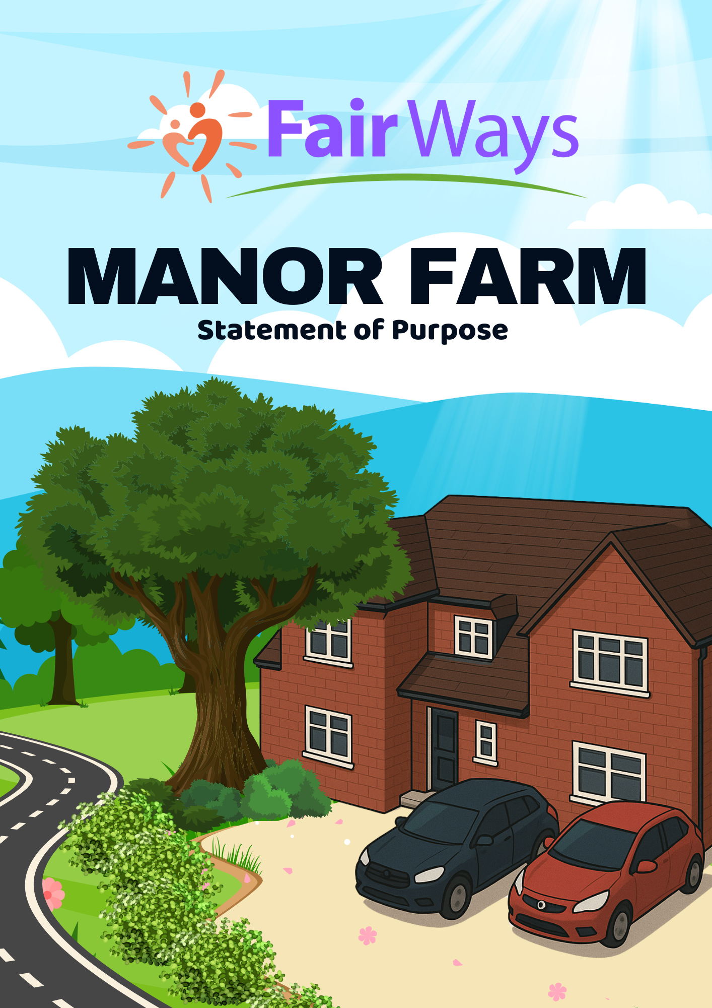
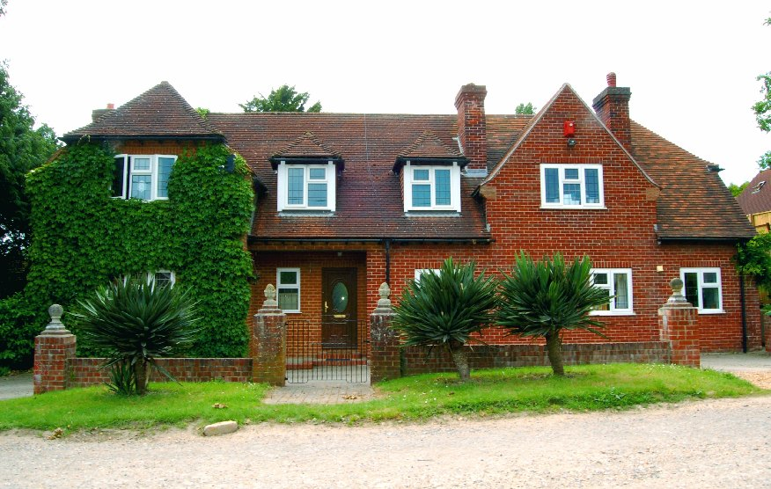
This Statement of Purpose has been prepared to meet the requirements of The Children’s Homes (England) Regulations 2015 Regulation 16 - (1) Schedule

Contents

Quality and purpose of care

- Statement of the range of needs of the children for whom it is intended that the children’s home is to provide care and accommodation.

- Details of the home’s ethos, the outcomes that the home seeks to achieve and its approach to achieving them.

- A description of the accommodation offered by the home, including
  - How accommodation has been adapted to the needs of children;
  - the age range, number and sex of children for whom it is intended that accommodation is to be provided; and

- A description of the location of the home.

- The arrangements for supporting the cultural, linguistic and religious needs of children.

- Details of who to contact if a person has a complaint about the home and how that person can access the home’s complaints policy.

- Details of how a person, body or organisation involved in the care or protection of a child can access the home’s child protection policies or the behaviour management policy.

Views, wishes and feelings

- A description of the children’s homes’ approach to consulting children about the quality of their care.

- A description of the home’s policy and approach in relation to -
  - Anti-discriminatory practice in respect of children and their families; and b
  - Children’s right

Education

- Details of provision to support children with special educational needs

- If the home is dually registered as a school, details of the curriculum provided by the home and the management and structure of the arrangements for education

- If the home is not registered as a school, the arrangements for children to attend local schools and the provision made by the home to promote the educational children’s educational achievement

Enjoyment and achievement

13. The arrangements for enabling children to take part in and benefit from a variety of activities that meet their needs and develop and reflect their creative, intellectual, physical and social interests and skills

Health

14. Details of any health care or therapy provide, including –

- Details of the qualifications and professional supervision of the adults involved in providing any healthcare or therapy; and

- Information about how the effectiveness of any healthcare or therapy provided is measured, the evidence demonstration its effectiveness and details of how the information or the evidence can be accessed

Positive relationships

15. The arrangements for promoting contact between children and their family and friends.

Protection of children

- A description of the children’s home’s approach to the surveillance and monitoring of children.

- Details of the home’s approach to behavioural support, including information about-

  - the home’s approach to restraint in relation to children; and
  - how persons working in the home are trained in the restraint and how their competence is assessed.

Leadership and management

- The name and work address of –
(a) The registered provider;
  - The responsible individual; and
  - The registered manager

- Details of the experience and qualifications of the team, including any adults commissioned to provide education or health care.

- Details of the management and staffing structure of the home, including arrangements for the professional supervision of adults, including those that provide education or health care.

- If the team are all of one sex, or mainly of one sex, a description of how the home promotes appropriate role models of both sexes.

Care planning

22. Any criteria used for the admission of children to the home, including any policies and procedures for emergency admission.

Quality and purpose of care

1. The range of needs of the children and admission criteria

Manor Farm Cottage (MFC) provides long term therapeutic care for up to 5 children. We have a carefully devised admission procedure which will consider the holistic needs of the child.
An impact assessment is completed prior to any admission to ensure children are matched as well as possible.
The admission of a new child, whether planned or unplanned, may be a difficult time and we aim to make any transition as smooth as possible. During the referral process consideration will be given to how the child would adapt to the new environment, placing emphasis on how the home can meet the needs of the child, without there being too much impact on the existing group of children.

We support children between the ages of 6 and 18 who:

- Require a residential alternative to a family placement.
- Have suffered multiple placement breakdowns.
- Have Social, Emotional & Mental Health difficulties.
- Suffer from attachment difficulties.
- Present challenging behaviour
- May have had police involvement.
- Have been neglected or abused.
- Have suffered trauma and loss.
- Present age-inappropriate sexualised behaviour
- Are in mainstream or special education.
- Have mild learning difficulties.
- Have ASD or other neurodevelopmental needs.

Placements cannot be considered for:

- Children who are addicted to hard drugs
- Children who set fire
- Children who persistently go missing
- Children who require continuous psychiatric supervision
- Children who pose a serious physical threat to themselves or others
- Children who have severe learning or physical disabilities.

Admission of any child in a planned or emergency manner would be subject to receipt of the relevant paperwork and the arrangement of a planning meeting, either on admission or within 7 days of the placement commencing. (72 hours for emergency admissions).

Social Workers or placements officers are welcome to call our referral line on 07808351142 or Pawel Skraba (Registered Manager) directly on 07566766902 Christine Reed (Deputy) on 07548836436 or Laura Rowe (Director of Operations, RI) on 07467 220077

2. Ethos, outcomes, and approach

Visual representation of our philosophy of care inspired by Kim Golding’s House Model of Parenting

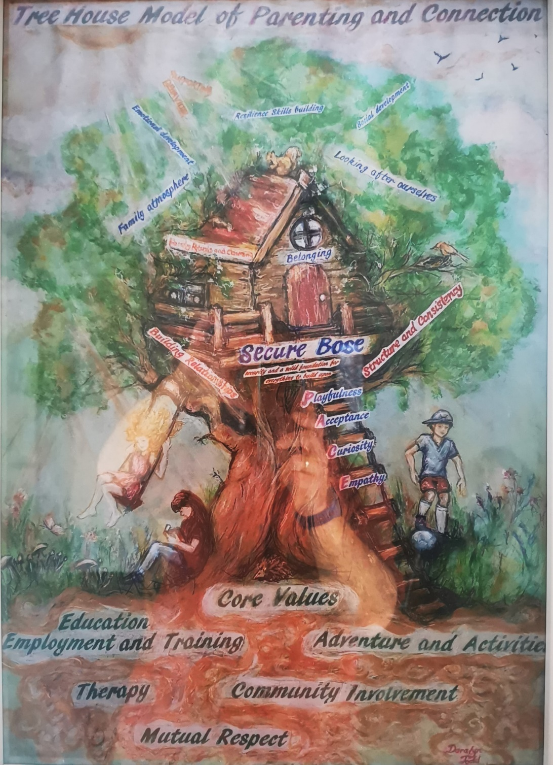

Manor Farm Mission Statement

At Manor Farm, we believe in the possibility of healing from the effects of adverse childhood experiences and developmental trauma. Our aim is to ignite such healing through building and sustaining meaningful, trusting, and reciprocal relationships.
We provide a safe, holding environment for the children, so that the child could embrace loving care, feel seen and heard, expand on their positive experiences, and reach their full potential.

CORE VALUES OF MANOR FARM COTTAGE

- Education, Employment and Training:
Every child at Manor Farm Cottage is supported and encouraged to engage in education, training or employment.

- Play, Adventure and Activities:
Children need, play, fun, enjoyment and challenges as part of their childhood. They need to be able to test/refine their abilities, have new and exciting experiences, challenge their fears and be able to safely explore risks as well as build the positive relationship with adults while engaging in various forms of playful activities. Manor Farm encourage this through locating and organising various types of adventures, experiences, and activities.

- Therapeutic Interventions
We understand that the therapeutic interventions are not something that can be delivered exclusively through the formal therapy sessions. We see every interaction with the child as an opportunity to therapeutically intervene so that child’s distorted internal working model can be confronted. Such an approach requires MFC to be truly reflective community and we strive to be one. When the need for a formal therapy is identified, the children are supported to take part in provided sessions, whether this be individual or family based, in line with the child’s needs and wishes. Assessments are also organised and facilitated to ensure a child’s individual support is understood.

- Community involvement:
It’s important for children to be and feel a part of the Manor Farm community and wider network. Weekly community meetings, day-to-day upkeeping of the home and partaking in community activities all support this. The children are a part of agreeing the values to be upheld by everyone and are supported to challenge them appropriately if improvements or adaptions may be needed.
Charity events and giving is also encouraged and supported – to give them a sense of agency in helping other people as well as belonging to the wider community.

- Mutual respect between all community members:
We listen and we try to understand and accept each other. We understand that at times we go through difficult periods when our behaviour may be challenging, however, we will not tolerate violence towards other community members, bullying or damage to property.

At Manor Farm Cottage, we seek to provide a therapeutic environment for children whose needs may be complex, often presenting behaviours that are the result of the child experiencing significant trauma.

The children at Manor Farm Cottage may have experienced rejection or separation from their families. They may have experienced physical, emotional, or sexual abuse, had multiple placements, been excluded from (or under achieving in) mainstream education, had episodes of going missing, or have been displaying offending or self-harming, behaviour.
Children may have underlying mental health issues, a history of substance misuse and/or be at risk of child sexual exploitation. Many may experience difficulties in establishing and maintaining positive relationships (with peers and adults) and be unwilling or unable to express their own feelings.

Children at Manor Farm Cottage have the right, and must be enabled by adults, to feel safe and be safe. They are supported to understand how to protect themselves and keep themselves safe – through exposure to well thought through risks, feel protected and safe and be protected from significant harm.
To achieve this, Manor Farm Cottage recognises the importance of the home’s team adhering to our therapeutic ethos and places a strong value on making positive relationships with children. This generates a culture of openness and trust and ensures that adults remain alert and are aware of any signs that might indicate a child is in any way at risk of harm.

This allows the children to feel confident and be able to tell someone they trust about any concerns or worries they may have.

The home is designed to offer the child a period of stability while intensive task focused work is undertaken with them. Our focus is to support and encourage the emotional, social, and physical development of each child through maximising the benefits of strong and positive relationships, alongside the provision of a range of opportunities for learning.

THERAPEUTIC MODEL
Our practice is informed by attachment theory and its specific practical implementation in the form of PACE - based model of therapeutic care. Within this model we aim to give the children a significantly different experience of care – one that can start the process of recovery from developmental trauma. Recognising that the healing process depends on the quality and strength of our relationship with the children we care for, we aim for our team to be trained in Dyadic Developmental Psychotherapy developed by Dr Dan Hughes – level 1 (DDP) as from this modality PACE arises.

We strive to train our team in DDP Lv1 within their first 18 months of employment. We recognise the need for adult’s ongoing development in their capacity to provide the children with therapeutic care. We create the space whereby such a learning is most effective. The team are provided with clinical group supervision as well as group reflective practice sessions. In these safe spaces, adults can reflect on their own practice, emotional responses to difficult situations, and look in depth into the communicative function of behaviour, including their own. These sessions prevent and counteract the effects of secondary trauma and blocked care.

Overview of our PACE-based model of Parenting
PACE is a way of thinking, feeling, communicating and behaving that aims to make the child feel safe. It is based upon how parents connect with their very young infants. As with young toddlers, with safety the child can begin to explore.

PLAYFULNESS
This is about creating an atmosphere of lightness and interest when you communicate. It means learning how to use a light tone with your voice, like you might use when storytelling, rather than an irritated or lecturing tone. It’s about having fun and expressing a sense of joy.

It is similar to parent-infant interactions when both parent and infant are delighting in being with each other and getting to know each other. Both are feeling safe and relaxed, neither feels judged nor criticised. Playful moments reassure both that their conflicts and separations are temporary and will never harm the strength of their relationship.

Having a playful stance isn’t about being funny all the time or making jokes when a child is sad. It’s about helping children be more open to and experience what is positive in their life, one step at a time.

Sometimes a troubled child has given up on the idea of having good times and doesn’t want to experience and share fun or enjoyment. Some children don’t like affection or reject hugs. A playful stance can allow closeness but without the scary parts.

When children find it hard to regulate their feelings, anger can become rage, fear, terror, despair and sadness. If this is the case, then children may also find it hard to regulate feelings of excitement, joy and love. Feeling these emotions can sometimes turns to anxiety.

Playfulness allows children to cope with positive feelings. It also gives hope. If you can help the child discover their own emerging sense of humour, this can help them to wonder a little more about life and how come they behave in the ways that they do. When children laugh and giggle, they become less defensive or withdrawn and more reflective.

A playful stance adds elements of fun and enjoyment in day-to-day life and can also diffuse a difficult or tense situation. The child is less likely to respond with anger and defensiveness when the parent has a touch of playfulness in his or her discipline. While such a response would not be appropriate at the time of major misbehaviour, when applied to minor behaviours, playfulness can help keep it all in perspective.

ACCEPTANCE
Unconditional acceptance is at the core of the child’s sense of safety.

Acceptance is about actively communicating to the child that you accept the wishes, feelings, thoughts, urges, motives and perceptions that are underneath the outward behaviour. It is about accepting, without judgment or evaluation, their inner life. The child’s inner life simply is; it is not right or wrong.

Accepting the child’s intentions does not imply accepting behaviour, which may be hurtful or harmful to another person or to self. The parent may be very firm in limiting behaviour while at the same time accepting the motives for the behaviour.

One hopes that the child learns that while behaviour may be criticised and limited, this is not the same as criticising the child’s self. The child then becomes more confident that conflict and discipline involves behaviour, not the relationship with parents nor her self-worth.
Curiosity is the foundation of acceptance of whatever underlies the behaviour. Making sense of how the child has learnt to behave in certain ways can help with acceptance.

CURIOSITY
Curiosity, without judgment, is how we help children become aware of their inner life, reflect upon the reasons for their behaviour, and then communicate it to their parents or therapist. Curiosity is wondering about the meaning behind the behaviour for the child. Curiosity lets the child know that the adults understand.

Children often know that their behaviour was not appropriate. They often do not know why they did it or are reluctant to tell adults why.

With curiosity the adults are conveying their intention to simply understand why and to help the child with understanding. The adult’s intentions are to truly understand and help the child, not to lecture or convey that the child’s inner life is wrong in some way.

Curiosity involves a quiet, accepting tone that conveys a simple desire to understand the child: “What do you think was going on? What do you think that was about?” or “I wonder what…?”

You say this without anticipating an answer or response from a child. This is different from asking the child, “Why did you do that?” with the expectation of a reply.
It is not interpretation or fact gathering. It’s just about getting to know the child and letting them know that.

Curiosity must be communicated without annoyance about the behaviour. Being curious can, for example, include an attitude of being sad rather than angry when the child makes a mistake. A light curious tone and stance can get through to a child in a way that anger cannot. You might make guesses about what a child may be thinking and feeling, saying this aloud, and keeping it connected to the present. It can be about having a conversation, almost with yourself, with the child in the room, without anticipating a response.

If an adult can stay curious about why their child is behaving as they are, the child and adult are less likely to feel cross or frustrated. As curiosity is non-judgmental, this can help the child to be open to how they, and other children, are thinking and feeling. Curiosity lets the child stay open and engaged in conversations.

Children then start to reflect upon their own inner life with their parent and therapist and start to understand themselves. As the understanding deepens, the child can discover that their behaviour does not reflect something bad inside them, but rather a thought, feeling, perception, or motive that was stressful, frightening, or confusing and could only be expressed through their behaviour.

As the child communicates this to the adults, the need for the behaviour may reduce, and with that the behaviour itself. The child’s feelings about the behaviour may change, with less defensiveness and shame but more guilt, leading to less of the behaviour.

EMPATHY
Empathy lets the child feel the adult’s compassion for them. Being empathic means the adult actively showing the child that the child’s inner life is important to the adult and he or she wants to be with the child in their hard times.

With empathy, when the child is sad or in distress the adult is feeling the sadness and distress with them and lets the child know that.

The adult is demonstrating that he or she knows how difficult an experience is for the child. The adult is telling the child that they will not have to deal with the distress alone. The adult will stay with the child emotionally, providing comfort and support, and will not abandon them when they need the adult the most.

The adult is also communicating strength, love and commitment, with confidence that sharing the child’s distress will not be too much. Together they will get through it.

The role of the adults in the community is the key to the healing process. As well as meeting the young child’s basic needs, they satisfy their emotional need to feel seen, heard, safe, valued, respected, supported, empathised with and cared about. They provide positive role modelling, clear and consistent boundaries and role model appropriate behaviour. The children begin to recognise that adults can be reliable and there for them. These relationships enable the children to develop appropriate attachments based on trust, safety and respect.

Our home is not isolated from the rest of the community. Our ethos is to integrate our children into society as much as possible as part of their living-learning experience. All our children attend either our own school or local mainstream or special schools, with which we have close working relationships. We encourage them to cultivate appropriate friendships. We also encourage them to develop interests and hobbies and to take part in activities in the community which help build their sense of self and self-esteem, such as performing arts clubs and sports teams. When planning activities for our children we always balance the possible risks with the benefits of independence.

All the approaches we use at Manor Farm Cottage – including therapeutic interventions and behaviour support are child-centred and consistent with attachment theory.

Claiming and community rituals
As mentioned above, Manor Farm sees the importance in creating and sustaining a sense of community for all of our children. For the children to have a sense of belonging, before they move into our home, it is part of their transition plan to be given the home’s Guide for Children, have agency in their room colour choice, taken out shopping to help personalise their new bedroom and visit the home and children.
On their first day, adults ensure their favourite meal is cooked and allow the child to fully explore their surroundings and spend time with the adults/children.
Dinner times, the home’s monthly meal out, weekly community meetings and organised whole community activities (such as games nights, movie night, pamper sessions and trips out) are some of MFC’s rituals, as well as having a yearly outdoor activity-based holiday.

Community meetings
Community meetings are held twice a week and are used to consult the children about the operation of the home, to address current issues within the home e.g. peer dynamics, plans for activities and behavioural issues which are impacting on other members of the community. These give the children the opportunity to find their own voice, share their views and feelings, challenge their peers and adult members of the community, to develop empathy and to contribute to the development of the home.

Keyworking
Each child is allocated a named Key and co Worker. These workers seek to develop and sustain a strong, meaningful positive relationship with the child based on trust, consistency and resilience. The Keyworkers monitor issues arising in all aspects of the child’s life - emotional, behavioural, social, educational and health. They report to the Team Leader and the child’s Social Worker and take any necessary action required. The keyworkers also manage the child’s records, contribute to Placement Plans, Risk Assessments, and Individual Behaviour Support Plans. They provide reports for review, TAC, and planning meetings. They identify and undertake individual work with their key child which is planned, supervised and monitored by their line manager.

Recreation and Community Activities
Manor Farm Cottage offers a wide range of activities on and off site. Adults plan recreational activities with children as part of daily living. Weekly community meetings allow children to discuss their preferences and feed them into a weekly plan of activities. Activities need to be carefully planned to balance realistic activities and leisure pursuits in line with those a child would normally receive in a family or foster care environment.
Hobbies and interest-specific activities are organised for the children to allow them to explore what they enjoy, with new taster sessions to activities that they may not have experienced before – to expand on their interests and opportunities.

Services

Manor Farm Cottage is registered by OFSTED Unique Reference Number: SC066481 we operate in accordance with government regulations as a Children Home. MFC provides long term therapeutic childcare service for up to 5 children (boys and girls) who may have experienced, and suffered from various abuse, inadequate parenting, domestic violence, and other traumatic events. We are a member of The Children’s Homes Association. We attend regular practice forums, and training events and access a wide range of professional networking activity.
Our assessments, placement, and behaviour support plans, and supporting interventions are overseen by Fairways Clinical Hub practitioner who works in close collaboration with MFC management and team.

This allows us to:

- Bring psychological and therapeutic knowledge and expertise to inform, contribute, and complement our overall model of parenting.
- Demonstrate high clinical standards and evidence-based methodology to the stakeholders, including regulatory body (OFSTED)

Our working practices are consistent with the five principia of trauma informed practice as defined by Office for Health Improvement and Disparities (Published 2 November 2022)

- Safety
- Trustworthiness
- Choice
- Collaboration
- Empowerment

The services offered at MFC include:

- 24h care with 4 adults to 5 children staffing ratio during the day, and 1 waking night and one sleep in during the night.
- Access to full range of health care services
- Assessment of therapeutic needs of the child by clinical hub within first months of the placement
- Access to sensory profile assessment if required.
- Access to individual therapeutic intervention if required.
- Access and transport to local educational provisions.
- Supporting family time, through organising logistics and reasonable facilitation.
- Range of activities, hobbies, and holidays.
- Preparation for transition to foster care, reunification with family, or other provisions identified by the Local Authority Care Plan

3 A description of the accommodation offered by the children’s home, including:

How accommodation has been adapted to the needs of children cared for by the children’s home

Manor Farm Cottage is a substantial detached house. It comprises of 5 good sized bedrooms, 2 adult bedrooms, 2 bathrooms, 1 shower room and 1 toilet along with an open plan kitchen and dining area. We have a large living room with doors exiting to the idyllic and expansive garden area – with plenty of room for running, playing and relaxing. The living room is split into a seated area with TV and a “chill” area with a computer and gaming area. A staff office and utility room are also located within the home.
Manor Farm also has an annex that joins onto the home, where the manager’s office, mini kitchen and meeting room are located. Upstairs, alongside bedrooms and bathrooms, we have another large communal relaxation space, where children and adults may spend time together.

Each child is encouraged and able to decorate their bedroom to their taste to promote individuality and a sense of belonging. Each child’s bedroom is fitted with TV, draws and wardrobes. Some of our children have a dressing table, computer table (and chair), bookcase and vanity mirror – each child’s furniture also reflects their tastes and interests.

Our garden is fenced to ensure a safe parameter. The home meets fire safety standards regarding fire doors, alarms, emergency lighting and drills. All windows upstairs have a safety latch to prevent them from being open wide.
External doors are fitted with thumb lock, so that the children can gain independent access to the outside.
All external doors and children’s bedrooms are fitted with an alarm system operated by a mobile phone. The external doors are set nightly as a safeguarding measure, with individual bedroom doors only set for the children who may require its usage to signal for support in the night or who may pose a risk to themselves or others. Children are made aware of this support function when they arrive, and system usage is reviewed every 6-months to make sure it’s only in place for the children who need it – taking into consideration children’s thoughts and feelings.
We have two home vehicles to take our children to various educational, recreational, and individual specific outings. These are cleaned regularly and checked for safe usage daily.

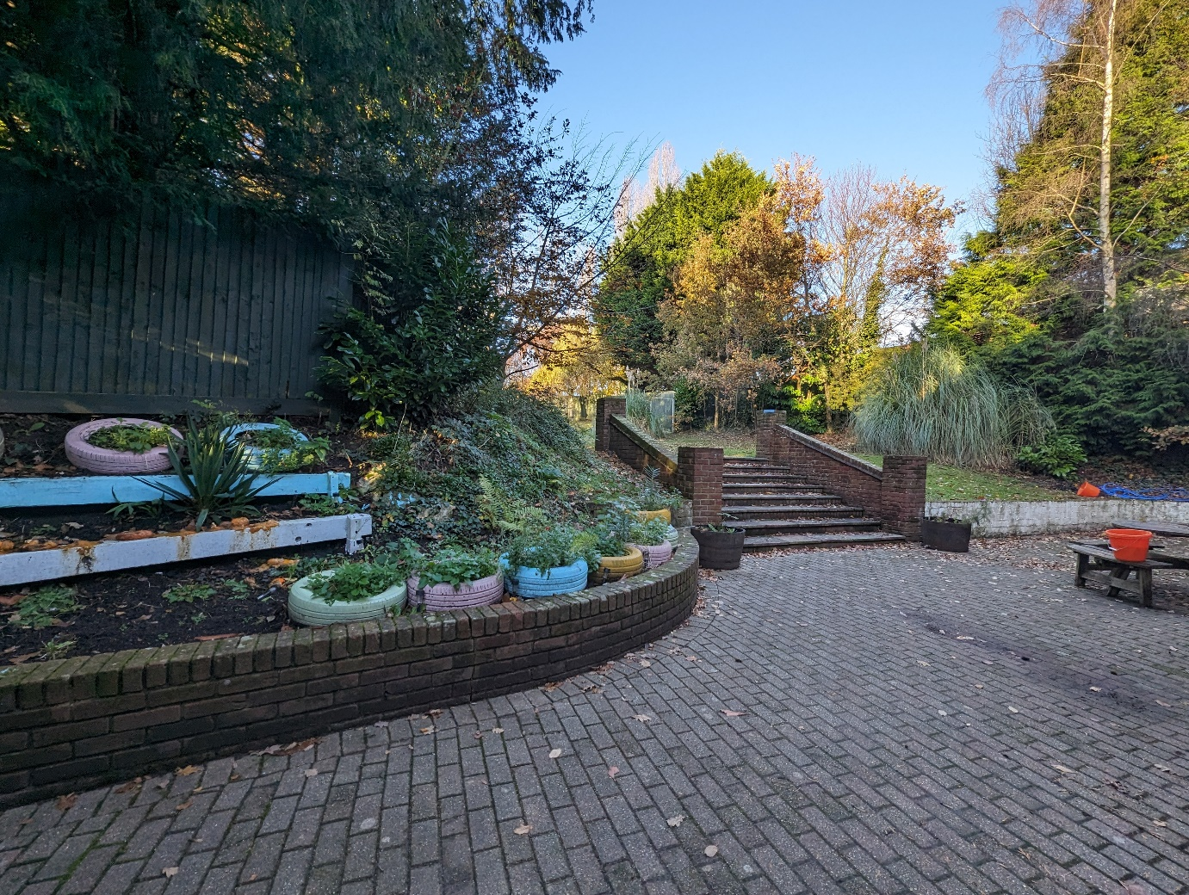

(b) the age range, number and sex of children for whom it is intended that accommodation is to be provided

Our children are aged between 6 and 14 years and we offer places for boys and girls. MFC provides nurturing, therapeutic care for up to 5 children. We are working in close collaboration with our sister home – Portchester Road which supports teenagers. This allows us to plan pathway plan for the children that still may require therapeutic residential support. This enables the children to continue receiving consistent care within wider Fairways community.

4 A description of the location of the home

Manor Farm is situated in Swanwick, which is a village in Hampshire, east of the River Hamble and north of the M27 motorway. It is within walking distance of Whiteley Shopping Centre and the smaller Locks Heath Centre.
The home’s location provides us with the easy access to parks and nature reserves. Within walking distance, the children can enter Swanwick Lake Reserve. The excellent road links e.g., M27 or A3 allow us to deliver a great range of outdoor activities such as walks and bike rides in the New Forest as well as seaside activities.
Proximity to Southampton gives us a good access to city-based undertakings – cinema, shopping, and other leisure activities.
Manor Farm’s Location strikes a fine balance between quiet, semi-rural area that naturally provides sense of safety and accessibility to various activities and opportunities for the children. Manor Farm Cottage location fits perfectly well within our core values and is directly linked to the value of play and outdoor adventures. We believe that connecting to and exploring the beauty of the nature plays a significant role in the process of healing and recovering from traumatic, early life experiences. We are using the opportunities given by the home location to achieve the best outcomes for our children.

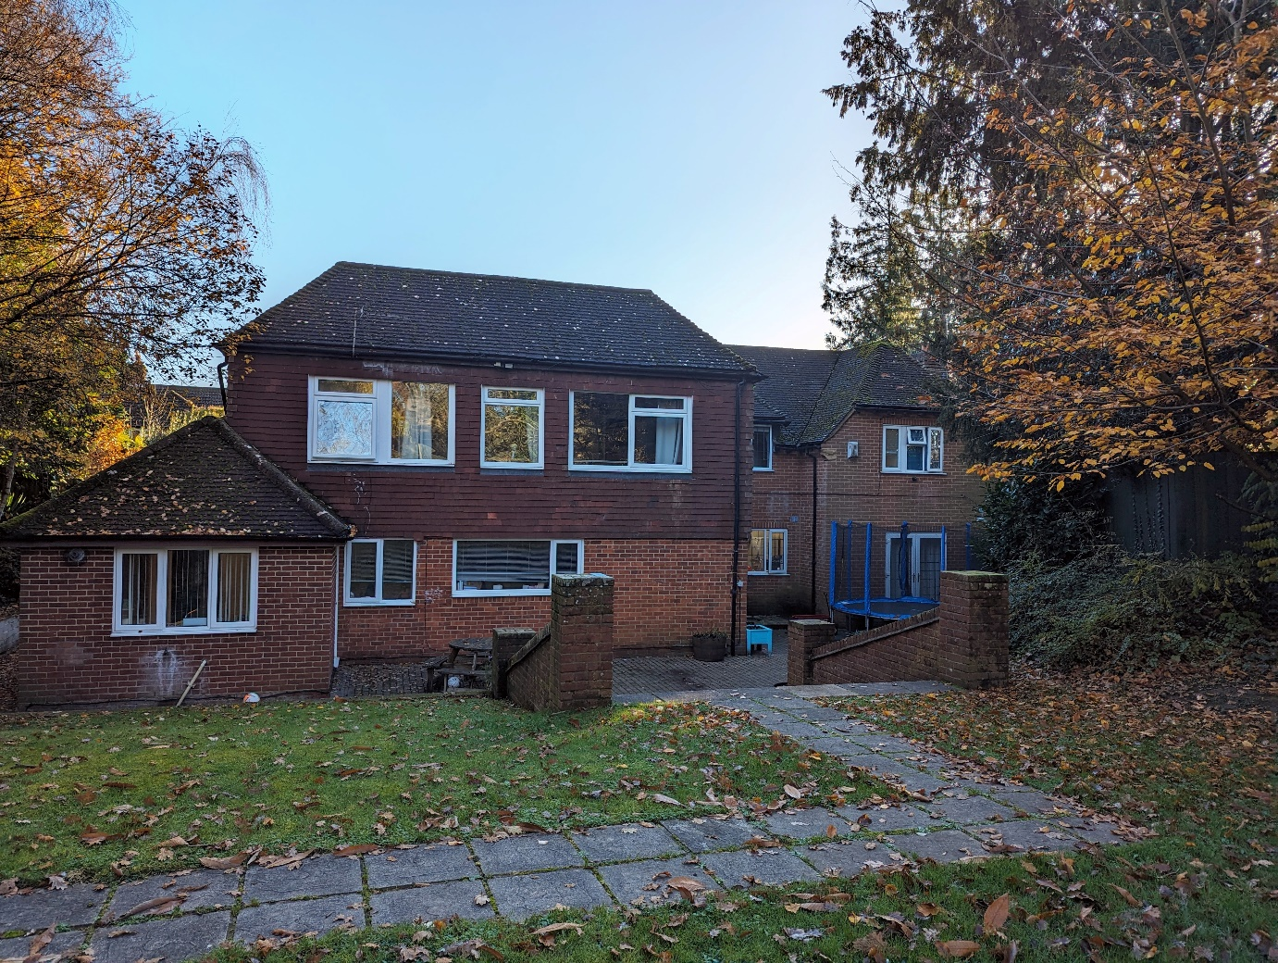

5 Supporting the cultural, linguistic, and religious needs of children.

Manor Farm Cottage welcomes children from all cultural backgrounds and supports them in holding and maintaining any religious beliefs and carrying out any spiritual practices they want to. The wishes of the children’s family in respect of their cultural/religious needs are, of course, taken into consideration. The home holds the view that discrimination is unacceptable, and everyone is expected to actively demonstrate tolerance, understanding and empathy for every individual. It is the policy of the home to ensure that each child receives care in an environment of anti-discriminatory, anti-oppressive practice, therefore the team are expected to recognise “differences” and actively support a child’s cultural, ethnic, linguistic, and religious needs as part of individual care.

Children can attend any appropriate religious service with adult support at established churches, mosques, temples etc., within the community, but are not obligated to do so. If required, we are able to support a child attending a place of worship of their choice within the local community. Adults will respect the child’s right to having a lack of faith.

6 Details of who to contact if a person has a complaint about the home and how that person can access the home’s complaints procedures.

If a complaint is made against Manor Farm Cottage, the work within Manor Farm Cottage or one of its employees, the complaint is taken seriously, the correct procedures followed, a thorough investigation carried out and an equitable outcome achieved.

On admission, children, their family and placing authority will be provided with information on how to complain, which will include a copy of the home’s complaints procedure.

The central principles for our complaint’s procedure are:
- The welfare of the child is paramount.
- Any concern about the quality of care must be fully explored.
- Investigations should be thorough, timely and consistent.
- All parties should be treated with dignity and respect.
- All children and adults will be supported and treated fairly.
- Adults will have an opportunity to respond to any concerns raised about them.

Complaints from parents
Complaints from parents will be recorded and addressed by the Manager of the home. If the Manager is unable to resolve the complaint, then Senior Management will be asked to try to arrive at a satisfactory outcome for all.

Failing this, the complaint will go to an independent person with no line management responsibilities who, if unable to resolve the matter in a satisfactory manner, may refer the complaint to OFSTED.

Complaints from children

Firstly, the complaint is listened to and recorded. The child will also be asked to write down their complaint, with help provided by an appropriate person if it is needed. If the adults on duty cannot deal with the complaint, then it will be taken to the Registered Manager or a member of the management team.

The complaint is recorded in the individual child’s complaint log. The complaint procedures are revisited with the children on a bi-annually basis.

The Social Worker and parents will also be informed if it is felt relevant. If the complaint is still not resolved, then Senior Management will be asked to try to resolve the issue. Failing this, the complaint will be passed to an independent person with no line management responsibilities who in turn may pass it onto OFSTED if a satisfactory outcome has not been reached.

Any complaint will be addressed seriously and without delay. A complaint will be fully responded to within a maximum of 28 days and children, parents and the placing authority kept informed of the progress.

N.B. Complaints by any party can be referred directly to OFSTED at any time. Their main office address is Piccadilly Gate, Store Street, Manchester M2 7LA. Telephone: 0300 123 1231.

Full details can be found in our Complaints Policy which is available on request.

7 Details of how a person, body or organisation involved in the care or protection of a child can access the home’s child protection policies or the behaviour management policy.

All the policies and procedures related to safeguarding and protecting children are available for all adults in electronic version on the Access system. The polices will be shared with relevant stakeholders on their request. This includes the behaviour management policy.
In addition, MFC created home specific Positive Behaviour Support Policy.
This policy highlights home’s focus on trauma informed approach to managing behaviour and outlines home specific strategies to support positive and sustainable changes in child’s behavioural presentation.

Safeguarding Officer and Policy

Manor Farm Cottage is committed to the principle that the welfare of the child is paramount (Children Act 1989). Any suspicion or allegation that a child has been abused while in Fairway’s care will be dealt with in accordance with this principle. This means that the company will seek to work with placing authorities and investigating authorities collaboratively and swiftly to progress investigations. At Manor Farm Cottage, the ‘Designated Person’ with lead responsibility for child protection is Pawel Skraba.

Any adults under suspicion of having abused a child will be immediately suspended while investigations are carried out.

Support workers who are told of allegations of child abuse or have reason to suspect that abuse has taken place must report details immediately to the home’s designated person, the Registered Manager. In the absence of the designated person, concerns must be reported straight away to a line manager (Team Leader), Deputy Manager, or to the Deputy Director of Residential Service, RI. There must be no delay in reporting caused by the unavailability of the designated person.

Telephone numbers:
Pawel Skraba, Registered Manager 07566766902
Christine Reed, Deputy Manager 07548836436
Eileen Calnan, Fair Ways DSO 07851251978
Laura Rowe, Director of Operations, RI 07823344410
Hampshire LADO 01962 876364
Hampshire Childrens Services 01329 225379
OFSTED 0300 1231231

All matters relating to child protection issues or concerns must be reported as soon as possible to the Registered Manager who will escalate to the relevant people.

Child Abuse is not always clear cut and the uncertainty about it can cause anxiety. The important messages are:

- Do not panic
- Share concerns with a more senior member of the team and approach the Registered Manager for an initial discussion
- Always act on the side of caution and report concerns quickly rather than adopt a policy of wait and see. This is crucial where there are allegations against or suspicions about a member of team or where there may be abuse of one child to another. Failure to report such concerns promptly can lead to suspicion of collusion or cover up.

Further details can be found in our Safeguarding Policy which is available on request.

Safeguarding Officer

Fair Ways designated Safeguarding Officer is Eileen Calnan. Eileen is responsible for ensuring that all safeguarding training delivered within Fair Ways is suitable and effective, that procedures and policies are accurate and true, and she is also available to advise, and assist should we have any safeguarding concerns.

Fair Ways Safeguarding policies are available on request from policies@fairways.co

Safeguarding children, preventing bullying.

Outcome: The welfare of children is paramount, children are protected from abuse, and an appropriate response is made to any allegation or suspicion of abuse (Quality Standard 12 The children’s Homes (England) Regulations 2015)

Principles:

This code of practice is based on the following principles:

- A child is a person under the age of 18.
- An acknowledgment that children can be victims of physical, sexual, and emotional abuse, neglect and bullying.
- Abuse can have serious and long-term effects on all aspects of a child’s health, development and well-being. Sustained abuse is likely to have a deep effect on a child’s self-image, self-esteem and future life.
- The safety and welfare of children is paramount and is the responsibility of all members of the team to help to prevent abuse and to act on any concerns.
- All children have the right to live in safety and to be protected from abuse.
- Children must be listened to, and any allegation or suspicion that they have been the victims of abuse or ill treatment will be taken seriously and responded to swiftly and appropriately.
- These principles will apply equally to all children irrespective of their race, culture, religion or belief, language, gender, age, disability or sexual orientation.
- MFC will take all reasonable steps to ensure that unsuitable people are prevented from working with children, through its recruitment practices, DBS checks and induction procedures.
- Adults at MFC are in a position of trust and should have a clear understanding of the responsibilities this carries, and they should not abuse their position. MFC recognises the potential of both men and women to abuse a position of trust.
- All members of the team have a duty to raise concerns, without prejudice to their own position, about behaviour of team members, managers, volunteers, students or others, which may be harmful to those in their care and will receive appropriate support when doing so.
- MFC is fully committed to providing on-going safeguarding training for all those working with children and will regularly review the operational guideline in place.

Safeguarding

Should a child disclose information of any abuse towards them, the Home Manager must be notified immediately. We are governed by legislation and mandatory practice when responding to child protection issues under the Children Act (1989) amended (2004) setting out organisational responsibilities to safeguard and promote the welfare of children across all sectors. Fair Ways will also follow the Department of Health Working Together to Safeguard Children (2015) guidance. Effective safeguarding arrangements in every local area should be underpinned by two key principles:

- Safeguarding is everyone’s responsibility: for services to be effective, each professional and organisation should play their full part.
- A child-centred approach: for services to be effective they should be based on a clear understanding of the needs and views of children.
- Manor Farm Cottage will continue to maintain professional relationships with local agencies to ensure the safeguarding and well-being of all children placed; this will also be outlined within the Local Safeguarding Children’s Board (LSCB) with the effective sharing of information in a timely way to promote joined up working and a robust safeguarding tool.

When disclosure takes place, the child should be reassured but told that it will be necessary for this information to be passed on to other adults (i.e. Home Manager, Director) and that such a conversation cannot be kept ‘confidential’.

Children must be listened to and enabled to report any allegations at the earliest opportunity. Adults should report any allegation of abuse immediately to a senior manager within the home.

All child protection issues should be taken seriously and in no circumstances, should they, or the disclosures, be taken lightly or ignored. These issues will be investigated according to the placing authority’s Child Protection procedures. Without exception, the case holder or their manager must be notified of the disclosure. If the disclosure occurs outside office hours, the emergency duty service of the placing authority must be notified, this information can be found within the individual child’s working files.

Radicalisation
Our aim is for all adults to be trained in the prevention of radicalisation and is committed to actively promoting the spiritual, moral, social, and cultural development of children in line with British values. The adults are trained to spot signs of behaviour, which undermine British values and have clear pathways to report any such behaviour through the channel process. We recognise the risks to children and children around radicalisation and have developed a policy which outlines how the organisation will minimise those risks for the children we support.

CSE
Looked-after children may also be particularly vulnerable to sexual exploitation by adults in the community. The NSPCC defines sexual exploitation as ‘being when someone grooms and controls a child for a sexual purpose’. The term ‘child sexual exploitation’ is used to refer to a range of illegal and abusive activities that can broadly be separated into two areas:
• Sexual exploitation through street grooming
• Online sexual exploitation

Where child sexual exploitation or the risk of it is suspected, the team must discuss the concerns with the home manager or the designated adult for child protection within their service. If after discussion there remain concerns, local safeguarding procedures must be triggered, including referral to local authority children’s social care and the police.

The support needs of the child concerned, including how they will be kept safe from intimidation and future exploitation, should also be discussed with statutory agencies and a joint plan of action agreed upon. At Manor Farm Cottage, we will use the CSE screening tool as part of the initial induction into the home for the children.

Bullying
Bullying is the intimidation or belittling of someone through the misuse of power or position which leaves the recipient feeling hurt, upset, vulnerable or helpless. It is often inextricably linked to harassment. Bullying can be either psychological or physical – both are equally distressing for the victim.

It is not uncommon that some children, especially those in a group living situations, attempt to use bullying tactics at some time. Research suggests that children from dysfunctional or abusive home environments are more prone to becoming either a target or a bully.

Regardless of the reason bullying has no validity at Manor Farm Cottage. We are proactive in our approach towards bullying and address incidents immediately. Children are supported to read and sign the anti-bullying pledge when they first join our community.

“Objectives should extend to the fundamental right of any child to dignity and protection from harm” Caring for Children Away from Home – DOH

We believe that children can be helped to develop better ways of behaving, provided that:

- There is a whole-hearted anti-bullying ethos which applies to both children and adults
- Everyone knows and understands what bullying is and why people may bully
- Everyone knows and understands that bullying is unacceptable
- Incidents of bullying are immediately dealt with
- A bully is called to account in a firm but supportive manners
- A bully is supported in learning more appropriate ways of interacting with other children as well as why they may feel the needs to use bullying behaviour.
- All children are encouraged and aided to be assertive
- All children are helped to identify bullying and to report it
- All children are empowered to help both the target and bully

Incidents of bullying are dealt with in a variety of ways, depending on the circumstances of the case and the characters involved. Where the children concerned have previously had a good relationship, or where there isn’t a long history of bullying behaviour, the “no blame” approach may be used. In other cases, both the bully and target are worked with individually and in the group setting. The dynamics of the situation are analysed, and an understanding is reached as to what factors are contributing to the problem. Work on building the self-esteem of both victim and bully may be undertaken. Adults may more closely supervise both parties. The target may be taught strategies for dealing with the situation, helped to be more assertive, or his/her awareness raised about collusion or taking on the victim role.

Using similar strategies, the ‘bully’ may be taught different ways of dealing with his anger or frustration and helped to develop empathy. The child may be placed onto the bullying protocol, which is designed to support them understanding the impact of their behaviour and support personal development and consideration, with rewards for improvement and appropriate consequences for continued bullying. Both individuals may be brought together to discuss the situation, the way forward and progress made.

Enabling a bully to look at their behaviour and the impact it has on others may be sufficient. However, if the behaviour does not modify sufficiently, the care plan will be revised – in partnership with the case holder. This may include involving external agencies and / or increasing staffing levels to maintain safety for all our children.

We are committed to resolving and preventing all forms of bullying and believe that this is achievable without termination of the placement. Only in extreme cases would we consider placement termination and when all other prevention and management options have been unsuccessfully explored.

Fair Ways believes that all children have the right to be treated with dignity and respect. We fully endorse an anti-bullying ethos to which both adults and children are committed.

Missing Child
It is explained to all children on admission, in language appropriate to their age and ability, that if they are away from Manor Farm cottage without permission the adults will be worried as to their whereabouts and safety and will have to take action to locate them and return them home. Manor Farm Cottage have an agreed Missing Person’s protocol with the local police and each child will have their own risk assessment for being absent from the home without leave.

The procedures when a child goes missing are as follows:

- The house and grounds are first thoroughly checked.
- The local area is searched after five minutes.
- Within 30 minutes (depending on the individual risk assessment) the Police are contacted to report the child missing or unauthorised absence. A full description of the child and the clothes they were wearing is given and the photo from their file used.
- The Registered Manager or on call manager is informed as are the other local homes.
- The child’s local authority is informed.
- All Information is recorded in the absent and missing child’s chronology report, including times. When any new information is gained the relevant children e.g., police, family, local authority and On-Call are informed.
- The child is responded to positively on their return and food and drink offered. A reflection with the child is held as soon as is appropriate.
- All relevant parties are informed. A return interview is to be requested from the Local Authority.

If there is any doubt regarding the safety of any child, the police will be notified immediately. Case holders and parents / carers are notified as soon as possible – dependent on wishes (some parents choose not to be informed during the night).

It is important that plans are made for the return of a child. Staffing numbers and planning should reflect the need to engage and support the child who may return in a negative frame of mind. Adults should always discuss the reasons for the non-return, the child’s whereabouts and who they were with at an appropriate time following their return; this is all completed on a return interview with the child.

Views, wishes and feelings

- A description of the children’s homes’ approach to consulting children about the quality of their care.

Children’s opinions, and those of their parents or other significant family members, Social Workers, Independent Reviewing Officers or others significant to the child, are sought over key decisions that are likely to affect their daily life and their future. Feedback forms are sent to Social Workers and IROs, school staff, other professionals who are engaged in childcare and to parents at regular intervals.

Children’s views may be explored in key work sessions, or in regular community meetings. The views of parents or significant others may be gathered during visits, by phone or by letter. All opinions expressed are promptly recorded and feedback given. We take the views of children, parents and placing authorities into account in the development and planning of changes in the operation of the home. Adults, and more specifically key workers, play an important role in these meetings, including supporting the child and enabling a clear understanding to be reached about the child’s views, wishes, feelings, and expectations for their future. We have an open-door policy, and the children are welcome to talk to management team at any time.

Anti-Discriminatory Practices

Manor Farm Cottage appreciates the specific needs of minority groups and pro-actively and positively works towards maintaining high standards in meeting these needs.

Positive adult role models are considered of the utmost importance in demonstrating kindness, respect, and fairness. Children are encouraged by this example to address any aspect of discrimination within the home. Manor Farm Cottage is a place which promotes and values diversity and equal opportunities.

We provide a home that does not tolerate any form of discrimination, whether direct or indirect, including those based on disability, sexuality, race, colour, sex, religion, or ethnic or social orientation.

All children and their families are treated with respect and accorded the maximum privacy, personal choice, and autonomy within the overall requirements for safety.

Manor Farm Cottage is committed to promoting and protecting children’s rights and we endorse and uphold the UN Convention on Children’s Rights. In providing support to children and children, we are committed to meeting their needs effectively and actively promote their rights.

9 A description of the home’s policy and approach in relation to-

- Anti-discriminatory practice in respect of children and their families; and
- Children’s rights

All our children’s homes are committed to promoting a positive and diverse culture in which all children and adults are valued and supported to fulfil their potential irrespective of their age, disability, race, religion, belief, sex, or sexual orientation. All children and their families will be treated with respect and accorded the maximum privacy, personal choice, and autonomy within the overall requirements for safety.
Fair Ways is committed to practices that uphold the principles of the following:
- Children Act 1989
- Children Act 2004
- Community Care Act 1990,
- Care Standards Act 2000
- Disabilities Discrimination Act 1995
- Sex Discrimination Act 1975/1986
- Race Relations Act 1976
- Human Rights Act 1998
- United Nations Convention on the Rights of the Child (Article 12)
- National Standards for the Provision of Children’s Advocacy Services 2003
- Children’s Homes Regulations including the Quality Standards (2015).

At Manor Farm Cottage, we encourage all children and adults to develop respect for themselves and others, encourage and support children to understand their rights and be well-informed about ways to challenge discrimination whilst fostering positive attitudes and relationships and a shared sense of cohesion and belonging. This is achieved by using platforms such as community meeting to discuss children’s rights and responsibilities, alongside individual conversations to help children understand the specific rights relating to their specific wishes and feelings.

Children placed at Manor Farm Cottage will be cared for by adults who have been suitably trained in all aspects of equality and diversity including legislation and their responsibilities through online training as part of their induction programme.

If you would like information on the rights of a child:
https://www.gov.uk/government/publications/united-nations-convention-on-the-rights-of-the-child-uncrc-how-legislation-underpins-implementation-in-england

Key worker
Manor Farm Cottage places a strong emphasis on making positive relationships with children through assigning key and co-workers along with working in a trauma-informed and accepting model of care (House Model of Parenting, PACE, DDP). Through promoting key working and building trusting and consistent relationships, there are many opportunities to converse, share and explore the wishes and feelings of the children that are placed with us.
Fair Ways offer ‘keyworker’ training designed and delivered by Manor Farm Cottage Deputy Manager in collaboration with the Head of Service and another adult Manor Farm Cottage. All support workers will attend within their induction period. Our keyworkers are responsible for knowing their key child’s history, their current needs, views and wishes, advocating for them, completing all necessary paperwork, attending CLA reviews and PEP meetings, engagement in parents’ evenings, and much more. They will also support their key child to attend playdates and family contact, plan for bedroom redecoration, find and attend a hobby, ensuring they have enough clothes and toiletries, etc.

Meetings
At MFC the children are invited to and attend various meetings whereby they can express their views, wishes, and feelings, and by doing so have the agency in decisions that affect their lives at MFC. The child, if requires, will always be helped by and adult to prepare for and during these meetings.
The community meetings are held twice a week and are integral part of MFC life. During the meetings various aspects of community life are discussed such as unresolved issues and disagreement, routines and boundaries, events in the big world that may affects community, appreciation, weekly highlights etc.
The minutes from the meetings are recorded in community meetings logbook.

Education

Whilst we believe that all children should have the opportunity to receive education in a mainstream provision, we also recognise that for various reasons this is not always possible. For these children we can provide alternative provision.

Children are encouraged to realise the importance of education and understand the implications in later life if they enter independence with no qualifications. Children can be educated at Manor Farm Cottage whilst they are awaiting the transition into an appropriate education provision. We support those who are entering higher education such as college and will provide transport to and from the educational centre giving them opportunities to achieve their aspirations. We may be able to provide transport to external education provisions.

Fair Ways has its own Ofsted registered school and a referral can be put forward if required and appropriate. The organisation also has its own ASD School in Totton and a Post 16 Education and Training facility in Fort Wallington, Fareham. All our educational packages are tailored around the needs and abilities of the individual child. Adults advocate strongly on behalf of children and assist in devising and supporting all educational plans.

At Manor Farm Cottage children have a specified time and area within the home in which to carry out homework with support available from the team.

Adults at Manor Farm Cottage work in partnership with the children’s education staff and Local Authorities to support children with Special Educational needs as identified through their Education Health Care Plans, IEP’s, PEP meetings and CLA Reviews.

10 Details of provision to support children with special educational needs

We recognise that for various reasons it is not always possible for children to attend mainstream education such as severe trauma, social, emotional, behavioural or learning difficulties. Children may have been out of education for long periods of time and may struggle to integrate into the mainstream classroom.
For those children that meet the age and educational requirements, Fair Ways has three of its own DfES registered schools including an education centre for special needs pupils aged between 11-19 years old. Further information on these provisions can be found at https://www.fairways.co/education/

For those children not meeting the age range or educational needs of the Fair Ways provisions, we have a good working relationship with two nearby specialist schools. Kingsgate School and Serendipity, which are all based in the Southampton area.

Further information on these provisions can be found at:
https://www.kingsgateprimaryschool.org.uk 01329 446 921
https://www.serendipity-education.com 02380 422 255

11. If the home is registered as a school, details of the curriculum provided by the children’s home and the management and structure of the arrangements for education.

Mannor Farm Cottage is not registered at a school. See next section.

12 If the home is not registered as a school, the arrangements for children to attend local schools and the provision made by the home to promote the children’s educational achievement.

As part of the educational opportunities that we like to promote within the home, we provide a computer with internet access to support education, homework and informal learning.
In addition, all children are provided with opportunities to extend their learning through school clubs and extra-curricular activities such as sport teams, homework clubs, music lessons, etc.

Adults at Manor Farm Cottage will attend the termly PEP/yearly EHCP reviews to ensure we are able to fully support the individual. In between reviews, regular communications with schools are important. We endeavour to keep educational provisions up to date with and current events, worries, feelings, and behaviours of the child, and vice versa; collaborative working allows for a better supported child.
Finally, we encourage and invite schools to attend our TAC meetings, so that all professionals directly involved in the child care can have the opportunity to meet and discuss most current developments and supportive strategies.

Enjoyment and achievement

13 The arrangement for enabling children to take part in and benefit from a variety of activities that meet their needs and develop and reflect their creative, intellectual, physical and social interests and skills

Recreational, Sporting and Cultural Activities
Manor Farm Cottage offers a wide range of activities inside and outside of our home. Adults plan recreational activities with children as part of daily living. Weekly community meetings allow children to discuss their preferences and feed them into a weekly plan of activities. Activities need to be carefully planned to balance realistic activities and leisure pursuits in line with those a child would normally receive in a family or foster care environment.

Children are actively encouraged to make use of all the facilities available locally and to develop hobbies and interests. Opportunities include:

- Scouts/Brownies
- Youth Clubs
- Performing Arts
- Skateboarding/BMXing
- Swimming
- Dance
- Martial Arts
- Bowling
- Horse-riding
- Football and Rugby
- Ice-skating
- Army, Navy, Police and Air Cadets
- Library

It is important for adults to be aware that children in care can easily become isolated from the local community. Keyworkers actively encourage community involvement for children if they are emotionally able to cope with the activities offered within the locality. Keyworkers investigate and develop links with all potential activity providers within the community setting, i.e., Scouts, dance classes and swimming club.
Children are also encouraged to learn and explore various cultures through organised cultural cuisine nights and other opportunities.

Every summer, MFC organises home’s holiday. For number of years now, this takes place in North Devon at Skerne Lodge – Outdoor Activities Centre.
At Christmas, we have a ritual of attending a Christmas Panto and other Christmas themed activities, such as Christmas markets. Children are also encouraged to contribute towards charitable giving over the Christmas period, alongside at various times throughout the year.

When appropriate, keyworkers organise the big days out with their key children. This may include e.g. the whole day trip to London, theme parks, concerts, football matches, public talks etc.

Health

14 Details of any healthcare or therapy provided, including-

Health Promotion
Arrangements are made to ensure that each child resident at Manor Farm Cottage is registered with a local GP. They will receive an annual CLA Health Assessment, optical and dental treatment related to their individual needs and that they live in a healthy environment where good health is promoted.

Adults monitor any changes in the state of the child’s health and arrange appropriate care or treatment after, obtaining if appropriate the child's consent, most medical problems are dealt with by our local G.Ps who keep full medical records of all our children. Every effort is made to ensure that past records are made available. They also perform medical examinations on admittance, periodically (as per regulations) throughout their stay and on departure. Where appropriate, children may choose whether they are accompanied by a member of our team to see their doctor, optician, dentist or nurse and where practicable, may see a doctor of either gender if they prefer. Adults encourage children to always maintain good personal hygiene and are encouraged to bathe or shower daily and wash their hair regularly.

Medication and other treatments are not given without the child’s consent or/and the consent of those with parental responsibility. All medicines are kept in a locked room and locked in the medical cabinet; prescribed drugs are to be given in accordance with the instructions provided. A designated adult on duty is responsible for ensuring that an accurate record is kept in the medication folder. All drugs are double signed for, as per the protocol issued by The Royal Pharmaceutical Society of Great Britain.

All children with any type of special medical needs are encouraged to attend specialist clinics e.g., ADHD, asthma, hearing etc. to promote positive health care.

A written record is kept of all doctors, optician or dental appointments with any treatment, prescribed medicines and any follow-up advice documented – which in turn could become part of the child’s Placement Plan.

The team has an important role in the health education of the children resident at Manor Farm Cottage. The Key Worker provides the child with guidance, advice and support appropriate to their age, needs, culture and wishes in relation to health issues. These may include alcohol and substance misuse, smoking, sex education, HIV infection, hepatitis and STDs. They are also taught about the benefits to health of good nutrition and diet, adequate exercise and rest, and personal hygiene. They are discouraged from smoking and alcohol/substance misuse.

The children are encouraged to contribute to the weekly menu planner, to make healthy eating choices and to try a variety of foodstuffs from all over the world. The menus are varied, child-friendly, tasty, and nutritious.

Clinical and Therapeutic Team
The (Hub) clinical and therapeutic department is based at Fort Wallington in Fareham. The Hub is a multi-disciplinary therapeutic service central to all other Fair Ways services. It is comprised of clinicians with various qualifications and sets of skills. The Hub works with all Fair Ways services to ensure children’s emotional, social and educational needs are identified through effective screening and clinical assessment. The Hub team works with other Fair Ways teams through supervision and training to ensure Fair Way’s children and child receive the most appropriate support and evidence-based interventions to help meet their needs. The Hub will deliver specific, time-limited evidence-based interventions where appropriate following a comprehensive clinical assessment.

The Hub also works with local mainstream and specialist services including wider professional networks to ensure seamless pathways for care and treatment and to help identify appropriate thresholds between The Hub and Community CAMHS.

If a child presents in mental health crisis the role of The Hub is to ensure the team seek emergency treatment for the child through the appropriate physical and mental health services. The Hub does not act as an emergency service and teams are supported and educated on appropriate care pathways in the case of an emergency.

The Hub’s own Statement of Purpose and the makeup of the Clinical team can be provided on request.

The Hub supports the following:

- Sensory profile assessment (if required)
- Direct 1:1 therapy or dyadic therapy (if required)
- Group reflective supervision and management reflective supervisions
- Training in a range of specific subject areas
- Chairing TAC meetings and assessing children’s developmental needs through this
- Ad hoc meetings to discuss specific situations for children
- Access to specific external assessments as required (e.g. Educational Psychologist)

Assessment
Chaired by the clinician, TAC meetings take place every two months for each child and are the main forum for the formulation of therapeutic interventions.
They represent ongoing process reviewing and assessing of the child’s developmental needs and effectiveness of our therapeutic interventions - linked to the child’s care plan outcomes and specifically with our child’s internal Placement Plan.

Individual therapy
The specific individual therapy may be delivered or sourced externally by the clinical hub should the need for such intervention be identified in the process of assessment the child’s therapeutic needs or arises at any stage of the child’s placement.

Outcome Measures
- Focus on qualitative data from key workers reports, key work sessions, TAC reports and discussions.
- Quantitative data from management reports including the longitudinal trends in the use of RPI, Incidents, Consequences, and rewards
- Internal Placement Plan designed to track changes of the child’s developmental needs through 6 monthly assessment of the progress against the baseline (the child’s needs on admission)

Staff Consultation, Supervision and Dynamics
Clinician attends team meetings to provide the team with the opportunity to explore the themes from day-to-day support of the individual children, the dynamics of the group, and interventions. This form of reflective supervision is one of the core elements of MFC practice.
During school terms, once a week, the management organises and facilitates the reflective session for the team on duty. The scope of this session is to look at, explore, and, if possible, address and resolve.

The hub may also offer individual clinical supervision for individual adults or the team where either they or their manager identify an additional support need.

The hub provides monthly individual reflective supervision for the Registered Managers and reflective supervision for deputies from four children’s homes.

Positive relationships

15 The arrangements for promoting family time between children and their family and friends.

Time for a child and their family is seen as an important factor in a child's residential experience and is actively encouraged and welcomed unless directions from the placing authority / court dictate otherwise.

All children at Manor Farm Cottage are supported in maintaining constructive time with their families, friends and other people who play a significant role in their lives.

Prior to admission family time arrangements are discussed, along with any restrictions to who they can/can’t see, and made clear to all parties concerned. Written guidance for adults is provided on the rights of children, parents and others to maintain time together, whether the family time needs to be supervised, and when and how to encourage parents and other significant children to take part in activities with the child in the home, at school or in the community.

If arranged in advance, Manor Farm Cottage adults can supervise time with family, although there is limited availability for this service.

All time with family is recorded, whether supervised or unsupervised.

Manor Farm Cottage makes use of local resources so that the family time can be as private and individual as possible.

If time with family is to take place away from the home, then transport arrangements are made and agreed with the family and the local authority in advance.

Children may be able to talk with their family/friends on the telephone after school times and before bedtimes; children can also have the use of the telephone at the home to call friends, relatives or family.

Protection of children

16 A description of the children’s home’s approach to the surveillance and monitoring of children.
Manor Farm Cottage employs minimal electronic surveillance in the home. The two methods the home utilises are:

Door Alarms
There are electronic door sensors on each external door and each child’s bedroom. The alarm system is only set up at night, when reduced team are on, and only for children’s bedrooms where it is felt necessary for safeguarding and support. This decision is reviewed every 6-months. Children and their local authority are made aware of their position prior to the child joining our community.
The alarmed sensors are connected to the team phone and will alert the adults to doors being opened.

Information relating to use of door alarms is recorded on the child’s Individual Risk Assessment and MFC will ensure that written consent is obtained from the Local Authority.

Night care is provided through either a waking night support worker and a member of the MFC/Fair Ways team who will be sleeping-in. There may be occasions that there are two adults on sleep in duty to provide this support and security for children throughout the night, depending on the needs of children and dynamic risk assessment on the night.

Digital security
We use Norton Internet Security system to monitor the appropriate use of the mobile phones, tablets, computers and other technological devices for the children who are allowed to have them. This is agreed with the social worker and child prior to children having their devices.
This is strengthened by Fair Ways internet security, which prevents access to certain platforms/websites when using the homes wifi.

During the set-up process of each child’s individual device, they are fully engaged and aware of the security measures in place, where device agreements are formed between child and keyworker to ensure that boundaries are clear and that each child understands fully before usage.

Through the Norton Security System, we have the ability for each child’s Keyworker to receive email notifications whenever “house rules” or “agreed terms” are breached to ensure this is address in a child centred way and keywork sessions can be completed to ensure the child progresses through learning.

Keyworkers are responsible to , and supported by their Team Leader, to complete regular E-Safety checks on the individual devices of each child. These are recorded within the E-Safety folder and each child is aware that these happen on a regular basis.

17 Details of the home’s approach to behavioural support, including information about-

It is accepted that consistent guidelines and controls form are an integral part of a child's development. As a child develops, they gradually internalise these controls and reduce the need for external reinforcement.

Adults are expected to help and support children to manage and control their own behaviour. The need for more formal consequences is reduced by clearly set boundaries of acceptable behaviour and achieved by high level of supervision with consistent and nurturing care practice, alongside natural consequences and modelled consideration that happen organically through the day. High standards of behaviour should always be encouraged as a normal part of day-to-day living. Reward praises form an important part of our behaviour support and are designed to encourage positive behaviour in the short and long term. By far the most effective tool the home uses to maintain discipline is the creative use of rewards. The home is very quick to recognise, reward and celebrate when children celebrating moments of success and growth. We understand that developmental trauma may strongly influence a child’s ability to accept and enjoy the rewards and praises. We are mindful of this phenomenon, and we always consider the individual child’s need in this respect. At Manor Farm Cottage we have a weekly rewards system that reflects on the child’s individualised weekly achievements, effort and focus on positive behaviour.

Formal consequences will only be used sparingly and after all other alternatives have been considered, to support children understanding the impact of their actions and inciting responsibility and accountability. If the need is felt to impose a formal consequence, the child will be informed, and the matter discussed with the Team Leader/Keyworker before deciding an appropriate sanction. Consideration will be given to the child's emotional state, understanding of their wrongdoing and the effect that imposing a sanction will have on future relationships.

Possible reasons for consequences:
- Damage to property
- Intent to harm others physically or emotionally (including bullying)
- Purposeful endangerment of self or others
- Breaching agreements
- If a child refuses to go to bed or disrupts other children when trying to sleep
- Constant disruptive behaviour within the home or at school
- Behaviour that results in extra or unplanned car journey

Acceptable consequences:
- Restorative meeting, key work session
- Reflective learning opportunities, that may include online learning, work sheets, or a conversation with their Social Worker or a PCSO.
- Incident-specific loss or restriction of privileges
- Temporary loss of TV, phone, or Wi-Fi (as per agreements)
- Reparation or restitution
- Extra household or community task
- Supervised spending of pocket money
- Cancellation of paid activity
- Being put on the bulling protocol

The ethos of the home is that control should be based upon good personal professional relationships between adults and children. Any guidelines suggested are not intended to cover every eventuality.
At Manor Farm Cottage, as a main behaviour correction tool, we use the natural consequences. These are used in day-to-day interactions with the children to help them to understand and follow social norms. They are non-punitive, parental interventions with easily indemnified therapeutic values.

Further details can be found in our Behaviour support Policy which is available on request.

Staff training & Competence

RiiSE
Care workers are trained and assessed in RiiSE (5 days course).
RiiSE is a trauma-informed behaviour support programme with core values at its heart, that are based on proactive, preventative, non-restrictive, RELATIONSHIP INSPIRED IDEAS to support behaviours that challenge within safe, SUPPORTIVE ENVIRONMENTS. RiiSE was developed to embed a therapeutic approach which informs all interactions, embraces a positive culture while we move towards becoming a trauma responsive organisation. RiiSE has roots in theories of trauma, attachment, restraint reduction and aspires to create a therapeutic culture and ethos for all, with adults able to proactively build and sustain the positive relationships and support the people we care for with compassion and empathy.
RiiSE will identify how adults can be agents of change, proactively build therapeutic relationships, sustain connection and provide a better quality of life.

RiiSE encompasses research from Kevin Ann Huckshorn, Kim Golding, Bruce Perry, Karen Treisman, Dan Siegel, Dan Hughes, Sarah Naish and John Bowlby, this is not the definitive list of theorists we draw upon, work from other theorists are included, but not limited to: Steven Porges, Bessel Van de Kolk, Nadine Burke Harris, Brene Brown and Patricia Crittenden. This wide repertoire of strategies informs and enhances knowledge and builds understanding to reinforce the impact of trauma and adversity on the children and adults we support. RiiSE teaches how to create a culture of safety, security and trust and embeds the importance of building and keeping positive relationships at the centre of all interactions and incorporate models such as ‘House Model of Parenting’ (Kim Golding), ‘PACE: Playfulness, Acceptance, Curiosity and Empathy’ (Dan Hughes) and the ‘Neuro-sequential Model of Therapeutics’ (Bruce Perry and the ‘Arousal Continuum’ () amongst others.
The RiiSE programme provides effective preventative de-escalation techniques and therapeutic strategies which emphasise a safer, supportive philosophy which has positive caring therapeutic relationships at its core.
Development of our RiiSE physical techniques was undertaken to ensure all techniques were rights-respecting. RIISE considers the below criteria when each of the techniques were risk assessed:
• Risk of psychological or emotional harm or re-traumatisation
• Whether the technique compromises the dignity of the person
• Potential for the techniques to intentionally inflict pain, with the use of pain compliance as a means of control
• Potential involvement of sensitive areas of person’s body (neck, chest, sexual areas)

This process involves a five-day course within the workers probation period. Care workers go through a continual assessment process throughout the five days - this involves monitoring the individual's attitude and skill set in de-escalation and prevention of the use of physical intervention as well as assessment of the knowledge of trauma informed practice in the end of the day 5th.
All workers attend Annual refresher courses in RiiSE to ensure continual development and assessment.

The principles relating to the use of Physical Intervention may be summarised as follows:

- Adults should have grounds for believing that immediate action is necessary to prevent a child from significantly injuring himself or others.
- Adults should take steps in advance to avoid the need for Physical Intervention, e.g., through dialogue and diversion and the child should be warned orally that Physical Intervention will be used unless she desists.
- Only the minimum force necessary to prevent injury or damage should be applied.
- Every effort should be made to secure the presence of other adults before applying Physical Intervention. These adults can act as assistants and witnesses.
- As soon as it is safe, Physical Intervention should be gradually relaxed to allow the child to regain self-control.
- Physical Intervention should be an act of care and support, not punishment.

Appropriate notes should be recorded in relation to all Physical Intervention incidents and the incident communicated to management as well as other relevant members of the team. A record of the Physical Intervention must be recorded in the child's file on ClearCare.

After a suitable period of time the child's key worker should seek privacy with the child to discuss the incident and explore possible ways of this being avoided in the future (Re-attunement)
A record of any Physical Intervention occurring is sent to the child's social worker weekly.

Monitoring of behaviour and incidents
The Registered Manager & Deputy Manager monitor all incidents of behaviour support, discipline, and restraint to identifying trends and patterns that will assist with improving

practice. The information from the analysis helps to inform our care planning, risk assessing and individual behaviour support plans.

Leadership and management
The Registered Provider & Manager, Including Qualifications

Manor Farm Cottage is owned by Fairways Community Benefit Society.

Company address: Manor Farm Cottage address:
Fair Ways, Manor Farm Cottage,
Ground Floor, Building 1000, New Road
Western Road, Swanwick,
Portsmouth, Southampton,
Hampshire, SO31 7HE.
PO6 3EN. 01489588900
02380 230400. .

Responsible Individual Laura Rowe Laura.Rowe@fairways.co
Registered Manager Pawel Skraba Pawel.Skraba@fairways.co

- Details of the experience and qualifications of staff, including any staff commissioned to provide education or health care.

Home Structure, Staffing, Experience & Qualifications
We believe that stability and consistency are an important factor in the lives of our children, and this is reflected in our shift pattern. Our shift pattern is a system whereby adults work 2 days on duty, followed by 4 days off, which avoids the daily changeover of teams that can be unsettling and disrupt continuity, one of the things we are looking to maintain. This shift pattern allows the team to create a more natural environment for the children and gives adults the satisfaction of being able to provide support for the children from dawn to dusk.

Details of staff experience and qualifications is available in MFC’s Work Force Development Plan which may be provided on request.

Laura Rowe  Director of Operations, Responsible Individual  (awaiting registration) | - PGCE  - BA Hons in Drama and Education Studies  - Level 2 Responsible Individual  - Corporate Governance  - Safeguarding at Director Level  - Over 20 years in education settings  - 7 years in managerial roles at Fair Ways including Headteacher, Head of Education  - Nominated Individual for CQC for over 5 years  - 5 years on Board of Directors supporting education, health, residential, family services and supported living  - MSC in Educational Leadership and Management
Pawel Skraba  Registered Manager | - MSc degree in Psychology,  - QCF Level 3 for Children and young people,  - QCF Level 5 Diploma in Leadership and Management for Residential Childcare,  - ILM Level 3,  - DDP Level 1 & 2,  - Theraplay Level 1,  - 20+ years of residential experience, over 15 years in residential childcare

- Details of the management and staffing structure of the home, including organisational chart arrangements for the professional supervision of staff, including staff that provide education or health care.

Manor Farms Staffing Structure:
Registered Manager
Deputy Manager
Administrator
3 teams - comprising of 3 Team Leaders, 3 Seniors, 6 Support Workers and;
2 Waking Night Support Workers.

MFC Organisational Chart

The whole team receive regular supervision with their line manager, to discuss the performance of the individual, key working issues and any child protection concerns. Supervision is regarded as a valuable two-way process which supports positive development.
Once a month the whole team attends reflective group supervision with a clinician from our clinical Hub.

Once a week during the school terms, the manager facilitates weekly reflective practice sessions with the team on duty. Both of these forums provide the team with opportunity to reflect on our practice from a trauma informed perspective.

All adults receive an annual appraisal with their line manager. This process tracks their development and forms part of their Personal and Professional Development Plan – which should be used at a point of reference within supervision sessions.

Induction Training consists of relevant information and guides to ensure safe and appropriate onboarding, taking into consideration the needs of the role and recognition of prior learning.

All new adults are required to complete specific online trainings within the first week of their employment. E.g. safeguarding children, medication, H&S, and fire prevention. Within the first months of employment new team members are trained in RiiSE, Recording and Reporting, Manual Handling, Food Hygiene, First Aid, and Medication Competency.

At the point of starting their employment, all new members of the team are provided with comprehensive Fairways Induction Workbook that contains comprehensive overview and detailed information regarding all aspects of induction process. The new team member works through the workbook with close support from their line manager.

In addition, at Manor Farm Cottage we designed our own induction document that is exclusively focused on presenting the home, its culture and ethos. Every new team member receives a copy of this document and works through this with support from the line manager.

Upon successful completion of the probation period, the new team member will be enrolled onto the Level 3 Diploma / Level 4 apprenticeship in Residential Childcare if it is not already held. Deputy Managers and Managers are required to complete the Level 5 Diploma in Leadership & Management.

Manor Farm Cottage has a workforce development plan available at the home which is available on request.

21 If the staff are all of one sex, or mainly of one sex, a description of how the home promotes appropriate role models of both sexes.

Manor Farm Cottage’s team is made up of a mix of both genders, which is positive for the children in our care to build relationships and learn to interact and can relate to in this dynamic. This also reinforces anti-discrimination and enables us to work with those children that find it problematic to relate to one or either of the sexes due to their experiences in childhood.

Care planning

22 Any criteria used for the admission of children to the home, including any policies and procedures for emergency admission.

Admission Criteria
Potential referrals will be carefully assessed by the manager to ensure that:

- The home is able to effectively meet the child’s needs.
- These needs fall within the home’s Statement of Purpose.
- Effective placement planning and risk assessment can be achieved should the referral convert into a placement.

To support the assessment, documents requested from the referring authority will include:

- The most recent statutory review report.
- All specialists’ reports e.g., psychology.
- School reports.
- Education, Health & care Plan (if applicable).
- The core assessment.
- Family tree.
- Any relevant court reports.
- Chronology of significant events on the child.
- The most up to date Risk assessments.

It is important that the placing authority provides detailed and comprehensive documentation about the child. This will enable the home to make an informed decision about the appropriateness of the referral including the capacity of the home to meet the assessed needs of the child, and any additional resources or services that may be required to achieve this.

As part of assessing the suitability of the referral, where appropriate the child should be visited in their current placement, provided with the opportunity to visit the home, and have the opportunity to be part of the decision-making process about the possible move. Meeting the adults and other children can diminish some of the anxiety they will understandably have about moving to another home and school. Where possible, a child’s parents/carers should also have the opportunity to be involved in this process.

For all new admissions the following forms are completed:

- Pre-placement checklist recording all documents received from the placing authority regarding the new admission.

- Pre-placement information / risk assessment of the child (to be completed by the placing social worker). The home must ensure that any risks identified are subsequently addressed in the child’s company risk assessment.

- Impact assessment this serves to identify the potential impact on the child of being placed in the home, together with the impact they may have on the established group and each individual within it.

We acknowledge that while we are skilled in working towards affecting change with children who display various challenging and difficult behaviours, there are some with whom we are unable to work. This includes:

- Those who are unwilling or unable to demonstrate a potential for change, growth and development.
- Those who have a history of persistent fire raising or arson with the intention of causing danger to life
- Those who purposely intentionally and regularly commit acts of violence towards other.
- Those who display a chronic recent history of serious self-harm
- Those who have been diagnosed as in need of a residential specialist psychiatric mental health secure unit or hospital.
- Those who are actively misuses drugs

However, all referrals will be treated and assessed on an individual basis following our referral and admission process.

All authorities that place a young person at MFC are required to fill in and sign pre-admission documents to cover agreement to such areas as:

  - Pre-Placement Checklist
  - CSE screening tool
  - Pre-Placement Information RA
  - Consent forms

Fast Track and Same Day Admissions
Whilst a planned placement is always preferable, there may be circumstances where it is appropriate to agree to the admission of an emergency placement i.e., an admission made within 24 hours of the initial referral contact. In such circumstances there is likely to be less information available about the needs and characteristics of the child.

We will only consider an emergency placement in exceptional circumstances once we have received an up-to-date Risk Assessment from the Local Authority. The local Authority must then attend a placement planning meeting within 72hrs of the Child’s placement at the home and provide all outstanding documentation.

Action Following Admission
The child’s bedroom will have been prepared in advance, be clean, tidy, warm and homely, and provided with appropriate toiletries.

On admission or as soon as possible thereafter, the child will have an informal meeting with their key worker and, if not already provided, be given an information pack containing information about life in the home including daily routines, pocket money, use of telephones, household jobs, activities, education and how to raise concerns, complaints and the fire evacuation procedure. The child will be given the opportunity to ask questions, meet other children, and adults. The induction checklist will be completed with the child.

An inventory will be made of all clothes and personal possessions bought in with the child. The adult responsible for the admission must ensure that the child has secure lockable facilities for storage of valuables and / or important personal possessions. They must be offered the opportunity to pass items of financial or personal value to the home for safe keeping. A record of all such items must be maintained, signed by the adult and the child.

Care must be taken to ensure that child’s health care/medication needs are not disrupted by the process of moving to a new home. The child must be registered with local primary health care providers (G.P., dentist, optician) and initial appointments made.

If not already received, consent forms e.g., for medication and medical treatment, must be obtained.

Within 7 days of the placement starting there should be a placement planning meeting involving the home, child, their family, and the placing authority.

The purpose of the placement planning meeting is:

- To formally reiterate the importance of the child having a voice in the process of planning for their future.
- To ensure no vital information has been missed in the matching and subsequent placement.
- To clearly set out from the start the specific expectations of the placement.
- To be precise about the level of support/interaction expected of the Social Worker and placing authority.
- To summarise for the child the expectations of group living and school attainments at the home.

Ongoing Planning
As part of ongoing planning, placement review meetings must take place within statutory timescales, in accordance with the Placement Planning Regulations.

The date of the first statutory review in placement will be agreed between the placing authority and the home at the time of admission. If this is not possible the IRO will be contacted and asked to set the CLA review date.

Whilst it is the responsibility of the placing authority to initiate statutory reviews, the home will be pro-active in advocating on a child’s behalf where there is any delay.

It is the key workers responsibility to prepare a written report for the statutory review under the guidelines contained in The Care Planning, Placement and Case Review (England) Regulations 2010. It is also the responsibility of the key worker to ascertain verbally, or in writing the child’s view(s) and wishes regarding the placement. In essence the key worker will ensure that they are fully prepared for the review, have a clear understanding of their role in the review process and will have facilitated the child being able to express their view or wishes.

The review process involves all professionals, the child, and relevant key members from their family. Key objectives and tasks are set within the planning forum to indicate work to be carried out on a range of criteria individual to the child.

The arrangements for the Team Around the Child meetings (TAC) and ongoing internal review

TAC meetings are one of the main tools for monitoring child’s progress at MFC, and a live review of the child’s progress in placement, aligning with their Placement Plan. These meetings are held every two months for each child and are chaired by Michelle Thompson, who works for the Fair Ways clinical hub team.
There is an expectation that the child’s school and social worker attend the meeting alongside with the child keyworker and MFC management. Wherever suitable, family members are also invited to attend.
Prior to the meeting, a comprehensive report is written by the keyworker and shared with the child’s wider network. The meeting aims to review the child’s progress in placement, their developmental needs, and the effectiveness of our interventions. TAC meetings support the reflection on the child’s presentation in all aspects of developmental needs, share the experiences of various professionals who are involved in the child care, and agreeing further therapeutic interventions.

Summary

Our overall aim is to provide a safe, nurturing environment in which the physical, social, intellectual, spiritual, and emotional development of every child is facilitated and differentiated according to need.

In responding to the individual needs of the young person, the home will at all times operate within the framework of the Children Act 1989, Children Act 2004, the Quality Standards (2015), the Children’s homes regulation (2015), The Social care common inspection framework (SCCIF) and Fair Ways’ childcare policies.

Manor Farm Cottage’s home’s operation will be evaluated regularly through Fair Ways’ Management via Regulation 44 visits and management schedules as detailed in Regulation 45, service purchasers and independent inspections through Ofsted.

From the Quality Standards (2015) all aspects of the following will be reviewed:
- Engaging with the wider system to ensure each child’s needs are met.
- The quality and purpose of care standard
- The Children’s views, wishes and feelings standard.
- The Education standard
- The enjoyment and achievement standard
- The health and well-being standard
- The positive relationships standard
- The protection of children’s standard
- The leadership and management standard
- The care planning standard

Date | Updated | Sent to Ofsted | By whom
01.08.2024 | - One adult went on maternity leave (Chloe Stevens)  - Two adults returned from maternity leave (Beth Devine and Amber Furniss)  - One adult returned from adoption leave and then moved from Senior Support Worker post to Admin post in different service (Kev Shelton)  - One adult moved from WN post to bank staff (Alanta Vincent)  - One adult (peripatetic) did not return from maternity leave (Aleksandra Musial)  - One adult moved from fixed term contract (maternity cover) to bank staff (Megan Lord)  - One adult moved from fixed term contract – maternity cover to WN post, and soon after to support worker post (Marnie Hurran)  - One adult promoted to Senior Support Worker post (Paula Miszewska-Birch)  - Four new Multisite Support Workers added | 01.08.2024 | Pawel Skraba
01.08.2024 | - Laura Rowe became Director of Residential, Family, and Education Services replacing Jonathan Loney | 01.08.2024 | Pawel Skraba
21.11.2024 | - Alanta Vincent joined as a Waking Night  - Bryn Gadd left Multisite Team | 22.11.2024 | Pawel Skraba
21.05.2025 | - Paula Miszewska-Birch left core staff team.  - Vicky Pelling left Multi-site team.  - Chelsea Mahoney, Emma Day, Chanelle Taylorson and Heidi Tiver joined the Multi-site team.  - Ofsted rating.  - Information on door alarms | 27.05.2025 | Christine Reed (sent to Ofsted by Pawel Skraba)
18.09.2025 | - Chelsea Mahoney left Multisite team  - Steve Evans joined Multisite team  - Jamie McCoy left MFC  - Stephen Stanbridge joined MFC  - Ellie Jewell achieved Lv4  - Gregg Riley achieved Lv3  - Abbie Cantwell achieved Lv3 | 18.09.2025 | Pawel Skraba
09.12.2025 | - Brief language review  - How children are supported to understand their rights and responsibilities  - Edits to therapeutic needs assessment  - Edits to Monitoring and surveillance  - Edits to Consequences | N/A | Christine Reed
16.01.2026 | - List of individual staff and their qualifications removed. This information is included in Workforce Development Plan and available on request. RI and RM qualifications and experienced updated  - MFC organisational chart added  - Head of Service changed to Deputy Director of Residential. | 19.01.2026 | Pawel Skraba
29.06.2026 | - Change to the age group supported at MFC. 6-18yrs, as per registration.  - Change to RI. Bret Noades replaced by Laura Rowe (awaiting registration) |  | Pawel Skraba

